
Bangalore University
VI- Semester BCA Project Report on
BYTELAB
Submitted by
VISHAL BALAKRISHNA SHENOY
U03EV21S0054
Under the Guidance of
PROF. VEENA N
M.C.A
DEPARTMENT OF COMPUTER APPLICATION- BCA


ISBR COLLEGE
16, 2nd main Rd, Electronics City Phase 1, Electronic City, Bengaluru, Karnataka 560100

ISBR COLLEGE
Department of Computer Applications-BCA
CERTIFICATE
This is to certify that the project entitled
BYTELAB
is a bonafide work carried out by
VISHAL BALAKRISHNA SHENOY
U03EV21S0054
fulfillment of VI Semester Bachelor of Computer Applications as prescribed by
BANGALORE UNIVERSITY during the academic year April 2024-June 2024

Mrs.Amsaveni Manigandan M

Asst. Professor HOD-BCA
Dept of Computer Application

PROJECT COMPLETION LETTER

Date:

This to certify that a Major Project titled “BYTELAB” is system used to detect the accident and report to emergency services , bearing University Register Number U03EV21S0054 and is being submitted in partial fulfilment for the award of the Bachelor of Computer Application of Bangalore University .The report has not been submitted earlier either to this University/Institution for the fulfilment of the requirement of a course of study.

KIRTHI.M is guided by DR.VEENA M, M.PHIL. ,PhD who is the Faculty Guide as per the regulations of Bangalore University.

Signature of faculty Signature of principal Signature of HOD

DECLARATION BY THE STUDENT

I hereby declare that “BYTELAB” is the result of the project work carried out by me under the guidance of our DR.M.VIJAYA MASHESWARI MCA, M.PHIL. , PhD in the partial fulfilment for the award of the Bachelor of Computer Application of Bangalore University.
I also declare that this project is the outcome of my own efforts and that is not been submitted to any other University or Institute for the award of any other Degree or Diploma or Certificate.

Place: Bangalore Name: VISHAL BALAKRISHNA SHENOY

Date: Registration no: U03EV21S0054

ACKNOWLEDGEMENT

Dreams never turn to reality unless a lot of efforts and hard work is put into it and no effort bears fruit in the absence of support and guidance. It takes a lot of effort to work my way through this goal and having someone to guide me and help me is always a blessing.

I would like to take this opportunity to thank a few who were closely involved in completing and executing this Project. At the outset, I thank God almighty for making my endeavor a success. I would like to express my sincere thanks to the Management of ISBR College for providing excellent infrastructure and other facilities, which enabled me to sharpen my skills. I would like to express deep sense of gratitude to HOD Mrs.Amsaveni Manigandan, Head of the Department, for providing us with adequate facilities, ways and means by which I was able to complete this project. I express my sincere gratitude to the Project Guide Dr.M.Vijaya Maheswari for his/her constant support and valuable suggestions without which the successful completion of this project would not have been possible.

I express my immense indebtedness to all the teachers and staff of Dept. of Computer Application, ISBR COLLEGE for their cooperation and support. At last I thank all others, and especially our classmates and our family members who in one way or another helped us in the successful completion of this work.

INTRODUCTION
I.INTRODUCTION
In today's educational landscape, where digital tools play an increasingly pivotal role, ByteLab emerges as a transformative solution designed to enhance the college laboratory experience for both students and faculty. This innovative web application is tailored specifically for college computer labs, aiming to streamline and elevate the management of lab sessions with efficiency and precision.

ByteLab empowers faculty members by providing a robust platform to monitor and assess students' lab activities throughout the academic year. By digitizing lab programs and automating the submission process, ByteLab simplifies administrative tasks while promoting active learning among students. Faculty can design and deploy lab exercises seamlessly, ensuring students have access to questions and tasks relevant to their coursework.

Central to ByteLab's design is its focus on facilitating student engagement through interactive problem-solving and submission mechanisms. Students can efficiently solve assigned questions and submit their responses through the platform, fostering a collaborative and educational environment. Real-time feedback mechanisms enable prompt evaluation and constructive guidance, ensuring continuous improvement in student performance.

ByteLab represents more than just a technological tool; it symbolizes a commitment to reshaping educational paradigms in alignment with contemporary demands. By harnessing digital innovation, ByteLab sets new standards in efficiency, accountability, and educational outcomes within college lab settings. As educational institutions embrace digital transformation, ByteLab stands as a beacon of educational excellence, preparing students for success in a dynamic and interconnected world.

1.1 ABSTRACT
ByteLab represents a pioneering web application tailored for college laboratory management, aimed at optimizing educational experiences for both students and faculty. It introduces an intelligent system that digitizes lab activities, automates assessment processes, and enhances interaction within the lab environment. By providing faculty with a robust platform to monitor and evaluate student progress, ByteLab simplifies administrative tasks and fosters a more engaging learning atmosphere.

At its core, ByteLab integrates advanced technologies to streamline lab operations. Faculty can effortlessly create and manage lab exercises, while students benefit from enhanced access to assignments and collaborative problem-solving tasks. Real-time feedback mechanisms ensure timely evaluation, enabling continuous improvement in student performance.

ByteLab's innovative approach not only improves efficiency but also supports personalized learning experiences tailored to each student's needs. By leveraging digital innovation and automated workflows, ByteLab sets new standards in educational excellence, preparing students to excel in an increasingly digital and interconnected world.

1.2 EXISTING SYSTEM

ByteLab joins a landscape of existing systems like Moodle, Canvas, and LabArchives, each designed to streamline college lab activities and enrich the educational experience. Moodle, a widely adopted learning management system, offers tools for course management and collaborative learning. Canvas, known for its user-friendly interface and extensive customization options, supports interactive teaching and learning environments. LabArchives specializes in scientific data management and collaboration, catering specifically to research-intensive lab environments. In comparison, ByteLab distinguishes itself with a focused approach on automating lab operations, optimizing student-teacher interactions, and fostering active learning through its intuitive digital platform.
Disadvantages:
- Complexity: Moodle and Canvas can be complex to set up and customize, requiring significant technical expertise and time investment from administrators and instructors.
- Cost: Implementing and maintaining these systems can be costly, especially for institutions with limited budgets, as they often require ongoing licensing fees and support costs.
- Learning Curve: Users, particularly new faculty and students, may face a steep learning curve when navigating these platforms due to their extensive features and customization options.

  - PROPOSED SYSTEM
ByteLab transforms college lab management by digitizing lab activities and simplifying student submissions. It offers a straightforward interface for students to complete their lab programs as per their syllabus. For faculty, ByteLab provides easy monitoring of student progress and performance, ensuring a smooth learning experience. ByteLab integrates seamlessly into existing educational setups, enhancing student preparation for today's digital learning environments.
Advantages:
- Focused Lab Management: ByteLab is specifically designed for college lab environments, providing tailored tools for managing and optimizing lab activities, which may be more specialized compared to broader educational platforms like Moodle or Canvas.
- Cost-Effective Solution: Institutions may find ByteLab to be a cost-effective solution compared to larger, more complex platforms that require extensive customization and ongoing maintenance.
- Simplified User Experience: ByteLab offers a user-friendly interface that simplifies the lab process for both students and faculty. It focuses on essential functionalities like lab program solving and submission, reducing the complexity often found in more comprehensive learning management systems.

REQUIREMENT ANALYSIS
II. SYSTEM SPECIFICATION
2.1 HARDWARE SPECIFICATION
- Processor: Intel i5 or above
- Hard Disk: 256GB or above
- Memory: 8GB or above

2.3 SOFTWARE SPECIFICATION
- Operating System: Windows 10 or above.
- IDE: Visual Studio Code, Pycharm.
- Browser: Google Chrome, Mozilla Firefox, Microsoft Edge.
- Front-End: HTML, CSS, Javascript.
- Back-End: Python with Flask.
- Database: MySQL.

III. SOFTWARE REQUIREMENTS
3.1 Functional Requirements:
- User Access Control: ByteLab must restrict student access to materials, allowing them only to solve lab programs and submit their work.
- Automated Submission Handling: The system should automate the handling of student submissions, ensuring efficient processing of lab program solutions.
- Real-time Feedback Mechanism: ByteLab needs to facilitate real-time feedback to students upon submission of their lab work, providing timely evaluation and guidance.
- Integration with Syllabus: ByteLab must integrate with the college syllabus to align lab program assignments with academic requirements.
- Data Security: The system must ensure the privacy and security of student data, including both transmitted and stored information.
- Scalability: ByteLab should be scalable to accommodate multiple students, faculty members, and lab sessions across different courses and departments within the institution.
- Compatibility: The system should be compatible with existing educational technologies and systems used by the college or university.

3.2 Non-Functional Requirements:
- Reliability: The system must be highly reliable, aiming for an uptime of at least 99.9%, to minimize disruptions during lab sessions.
- Availability: ByteLab should be available 24/7 to accommodate varying schedules of students and faculty members accessing lab resources.
- Maintainability: ByteLab should be designed for easy maintenance and updates to facilitate system enhancements and bug fixes with minimal downtime.
- Performance: ByteLab should maintain high performance standards under different network conditions and usage scenarios, ensuring consistent user experience.
- Security: The system must implement robust security measures to protect student data and ensure compliance with data privacy regulations.
- Interoperability: ByteLab must support standard protocols and formats to facilitate interoperability with other educational and administrative systems.
- Scalability: ByteLab should be able to scale efficiently to support a growing number of students, courses, and lab sessions without compromising performance.

4.FEASIBILITY STUDY
Technical Feasibility:
  - System Requirements: Assess the technical requirements to develop and deploy ByteLab, including hardware, software, and networking infrastructure.
  - Development Tools: Evaluate the availability and suitability of development tools and technologies needed to build ByteLab.
  - Integration: Determine the feasibility of integrating ByteLab with existing educational systems and infrastructure.
Operational Feasibility:
- User Acceptance: Gauge potential user acceptance and usability through consultations with stakeholders such as faculty and students.
- Training Needs: Identify training requirements for faculty and administrative staff to effectively use ByteLab.
- Operational Impact: Assess the impact of ByteLab on current operational processes within college labs and administrative workflows.
Economic Feasibility:
- Cost-Benefit Analysis: Conduct a cost-benefit analysis to evaluate the financial viability of developing and maintaining ByteLab compared to its expected benefits.
- Budget Allocation: Estimate initial development costs, ongoing maintenance expenses, and potential return on investment.
- Resource Availability: Determine the availability of financial resources, human resources, and time required to develop and implement ByteLab.
Environmental Feasibility:
- Infrastructure Impact: Assess the environmental impact of deploying ByteLab, including energy consumption and hardware disposal considerations.
- Sustainability: Explore opportunities to minimize environmental impact during the development and operational phases of ByteLab.

5.DEVELOPMENT MODEL
5.1 Introduction
The iterative model is a method of software development where the process is divided into small, manageable iterations or cycles. Each iteration involves planning, design, development, and testing, allowing for continuous improvement and adaptation based on feedback. This approach ensures that the final product is refined and meets user requirements more accurately.

5.2 Application
In developing ByteLab, the iterative model, specifically the prototyping approach, was employed to ensure the system met the needs of both students and faculty effectively. Initially, a basic prototype of ByteLab was created, focusing on core functionalities like solving lab programs and submitting them. This prototype was then presented to mentors and stakeholders for feedback.
Based on the feedback received, several iterations were conducted. Each iteration involved refining the prototype, adding new features, and addressing any issues or suggestions raised by the stakeholders. This cyclical process of development and evaluation allowed for continuous improvement of ByteLab.
As a result, ByteLab evolved through multiple iterations to become a robust and user-friendly platform that streamlines lab activities and enhances the learning experience. The iterative approach ensured that the final product was well-aligned with user expectations and effectively addressed their needs.

SYSTEM DESIGN

INTRODUCTION
In the context of modern education, managing college lab activities efficiently is crucial for enhancing the learning experience and academic performance of students. Traditional methods of lab management often involve manual processes that can be time-consuming and prone to errors. To address these challenges and streamline lab activities, we propose the design of ByteLab. ByteLab is a digital platform designed to automate and enhance the management of college lab sessions, providing a seamless and interactive environment for both students and faculty. By leveraging technology, ByteLab aims to improve the efficiency of lab sessions, ensure timely submission and feedback, and foster a more engaging and productive learning experience.

Purpose and Scope
The primary purpose of ByteLab is to transform the management of college laboratory activities by automating and digitizing key processes. ByteLab aims to streamline the submission and evaluation of lab programs, enhance the tracking of student progress, and provide real-time feedback to foster a more interactive and efficient learning environment. By addressing the limitations of traditional lab management methods, ByteLab seeks to improve the overall educational experience for students and faculty alike.
ByteLab is designed to cater to the specific needs of college laboratory settings. The system facilitates automatic handling of lab program submissions, reducing administrative overhead and errors. It provides real-time feedback on student submissions, promoting timely learning and improvement. ByteLab also allows faculty to effectively monitor student progress and performance throughout the academic term. With robust security measures, the system ensures the privacy and security of student data. Additionally, ByteLab is scalable, supporting the growing needs of educational institutions by accommodating an increasing number of students, courses, and lab sessions. It integrates seamlessly with existing educational technologies and systems, enhancing compatibility and user experience. By focusing on these areas, ByteLab aims to enhance the efficiency and effectiveness of lab management, ultimately contributing to a more productive and engaging academic environment.
MODULE DESCRIPTION
1.User Authentication and Access Control Module
- Manages user authentication to ensure secure access to ByteLab.
- Implements role-based access control to restrict student access to only solving and submitting lab programs.
- Ensures that faculty and administrators have the appropriate permissions to manage and monitor lab activities.
2.Lab Program Submission Module
- Facilitates the submission of lab programs by students.
- Automates the handling of submitted programs, ensuring they are properly categorized and stored.
- Provides confirmation to students upon successful submission of their work.
3.Feedback and Evaluation Module:
- Allows faculty to evaluate submitted lab programs and provide detailed feedback.
- Provides real-time feedback on student submissions to promote timely learning and improvement.
- Supports automated grading for specific types of lab programs to streamline the evaluation process.
4. Progress Monitoring Module:
- Allows faculty to monitor and track student progress and performance throughout the academic term.
- Provides visual dashboards and reports to help identify areas where students may need additional support.
- Includes features for tracking completion rates and performance trends over time.

5. Integration Module:
- Ensures seamless integration with existing educational technologies and systems used by the college or university.
- Supports data exchange with Learning Management Systems (LMS) like Moodle and Canvas.
- Facilitates integration with other administrative systems to streamline data management and reporting.
6. Security and Privacy Module:
- Implements robust security measures to protect student data and ensure compliance with data privacy regulations.
- Includes encryption of sensitive data and secure transmission protocols.
- Ensures regular security audits and updates to maintain system integrity.
7. Scalability and Performance Module:
- Ensures that ByteLab can scale efficiently to accommodate an increasing number of students, courses, and lab sessions.
- Monitors system performance and optimizes resource usage to maintain a high level of responsiveness.
- Provides mechanisms for load balancing and failover to ensure consistent availability.
8. Notification Module:
- Sends notifications to faculty when students submit lab programs.
- Includes options for email and in-app notifications to ensure timely alerts.
- Configurable settings allow faculty to customize notification preferences based on their needs.

ER DIAGRAM

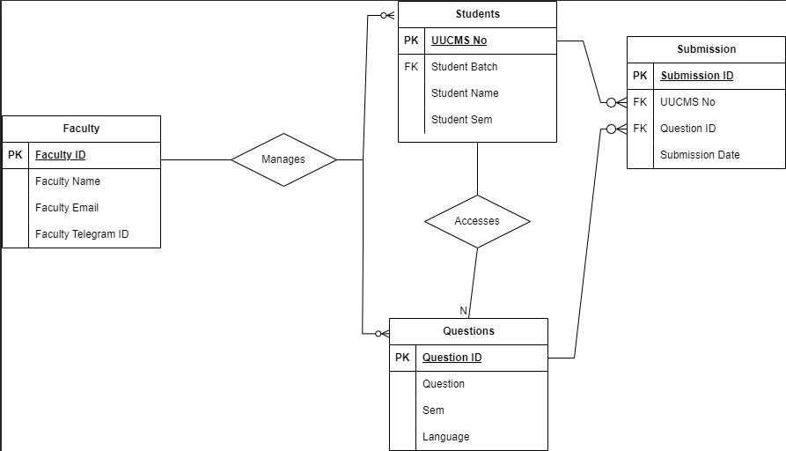
Explanation:
- Accidents: This entity represents the accidents detected by the system. Attributes include Accident_ID and Location.
- Vehicles: This entity includes information about the vehicles involved in the accidents, with attributes such as Vehicle_ID, Type, and Owner.
- Alerts: This entity stores the alert details that are generated when an accident is detected. Attributes include Alert_ID and Message.
- Notifications: This entity handles the notifications sent to emergency services, with attributes like Notification_ID, Time, and Status.
- Hospitals: This entity contains information about the hospitals that might receive notifications. Attributes include Hospital_ID, Name, and Contact_Number.
- Emergency Services: This entity captures the details of emergency services involved. Attributes include Emergency_ID, Service_Name, Contact_Number, and Location.

This diagram effectively models the key entities and relationships involved in an accident detection system, illustrating how data flows from detected accidents through to notifications sent to hospitals and emergency services.

DFD(Data Flow Diagram)
DFD LEVEL-0

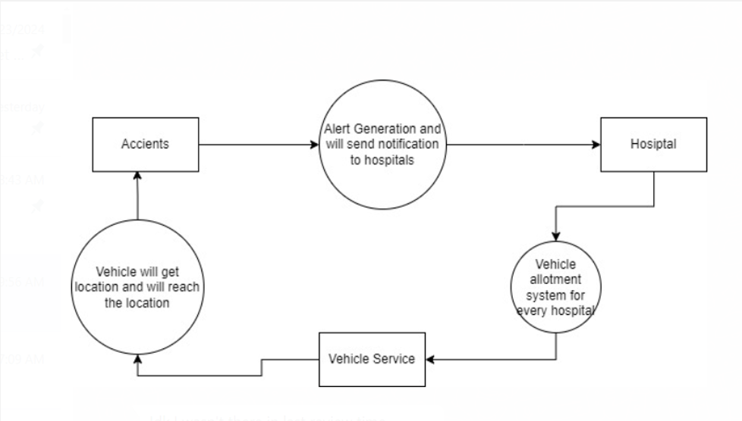

Explanation:
- The system detects an accident and generates an alert.
- The alert is sent to hospitals.
- Hospitals use their vehicle allotment systems to dispatch emergency vehicles.
- Vehicle services ensure vehicles are available and reach the accident location promptly.

DFD LEVEL-1

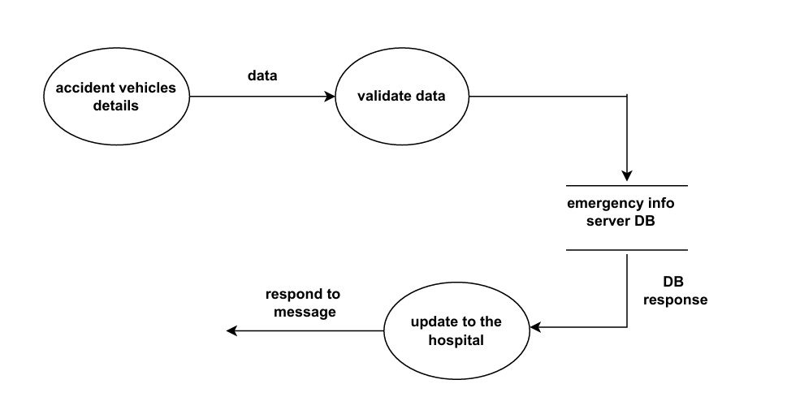

Explanation:
- Accident vehicle details are collected and validated.
- Validated data is stored in the emergency info server database.
- The database provides a response confirming the data entry.
- An update is sent to the hospital with the accident details.
- The hospital responds to confirm receipt of the information.

DFD LEVEL-2

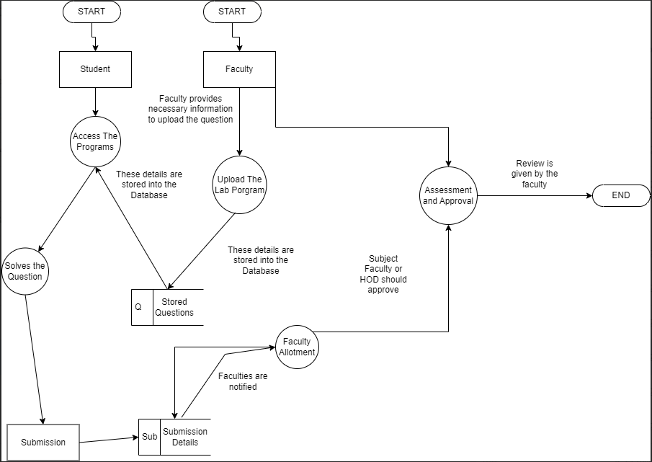

DEVELOPMENT, TESTING AND IMPLEMENTATION PHASE

SOURCE CODE
account_page.html
{% extends "dashboard.html" %}
{% block title %}{{ title }}{% endblock %}
{% block main %}
<div class="large container">
<table class="large">
<thead>
<tr>
<th>Title</th>
<th>Details</th>
</tr>
</thead>
<tbody>
{% for account_title, account_details in details %}
<tr>
<td style="padding: 0.5rem;text-align: left;">{{ account_title }}</td>
<td style="padding: 0.5rem; text-align: left;">{{ account_details }}</td>
</tr>
{% endfor %}
</tbody>
</table>
</div>
<button class="button">
<a href="/logout">Logout</a>
</button>
{% endblock %}

add_batch.html
{% extends "dashboard.html" %}
{% block title %}{{ title }}{% endblock %}
{% block main %}

<div class="large container">
<p style="font-size: 0.8rem;"><b>Note:</b> Please upload a CSV file containing the following fields in lowercase: <br><b>uucms_no, name, course, semester, batch</b>. The field names are case sensitive.</p>
<form class="large" method="post" enctype="multipart/form-data">
<input type="file" name="batch_file" id="batch_file_input" required>
<button type="submit" class="button">Add Batch</button>
</form>
</div>

{% endblock %}

add_course.py
{% extends "dashboard.html" %}
{% block title %}{{ title }}{% endblock %}
{% block main %}
<div class="large container">
<form class="large" method="post">
<input type="text" name="course_name" id="course_name_input" placeholder="Course Name" required><br>
<input type="text" name="course_full_form" id="course_full_form_input" placeholder="Full Form" required><br>
<input type="number" name="no_of_sems" id="no_of_sems_input" placeholder="Number of Semesters" min="1" max="6" required><br>
<button type="submit" class="button">Add Course</button>
</form>
</div>

{% endblock %}

Add_question.html
{% extends "dashboard.html" %}
{% block title %}{{ title }}{% endblock %}
{% block main %}
<div class="large container">
<form class="large" method="post">
<textarea name="question" id="question_input" class="large" placeholder="Question" required></textarea><br>
<input type="text" name="semester" id="semester_input" placeholder="Semester" required><br>
<input type="text" name="programming_language" id="programming_language_input" placeholder="Programming Language" required><br>
<input type="text" name="subject" id="subject_input" placeholder="Subject" required><br>
<button type="submit" class="button">Add Question</button>
</form>
</div>

{% endblock %}
Admin-dashboard.html
{% extends "dashboard.html" %}
{% block title %}{{ title }}{% endblock %}
{% block main %}
<div class="row-flex" style="gap: 3rem;">
<a href="/admin-dashboard/add-course" class="link">
<div class="card" style="min-width: 175px;">
<i class="fa-solid fa-graduation-cap icon"></i>
<label for="">Add Course</label>
</div>
</a>
<a href="/admin-dashboard/add-subject" class="link">
<div class="card" style="min-width: 175px;">
<i class="fa-solid fa-book icon"></i>
<label for="">Add Subject</label>
</div>
</a>
<a href="/admin-dashboard/add-faculty" class="link">
<div class="card" style="min-width: 175px;">
<i class="fa-solid fa-user-plus icon"></i>
<label for="">Add Faculty</label>
</div>
</a>

</div>
{% endblock %}

Base.html
<!DOCTYPE html>
<html lang="en">
<head>
<meta charset="UTF-8">
<meta name="viewport" content="width=device-width, initial-scale=1.0">
<title>{% block title%}{% endblock%}</title>
<!-- Styles -->
<link rel="stylesheet" href="https://cdnjs.cloudflare.com/ajax/libs/monaco-editor/0.47.0/min/vs/editor/editor.main.min.css" integrity="sha512-aXY4Jy2T87O1jn1kq2FQOEx/0sOXKOVJAi3FCY1qEm83zzqyckXh+wdkNi2ai2ltUe8ynV9ky/HcdPinXlXpsA==" crossorigin="anonymous" referrerpolicy="no-referrer" />
<link rel="stylesheet" href="{{ url_for('static',filename='styles/style.css') }}">
<link rel="stylesheet" href="https://cdnjs.cloudflare.com/ajax/libs/font-awesome/6.4.2/css/all.min.css"
integrity="sha512-z3gLpd7yknf1YoNbCzqRKc4qyor8gaKU1qmn+CShxbuBusANI9QpRohGBreCFkKxLhei6S9CQXFEbbKuqLg0DA=="
crossorigin="anonymous" referrerpolicy="no-referrer" />
<script src="https://unpkg.com/xterm"></script>
</head>
<body>
{% block body %}
{% endblock %}

<!-- Scripts -->
<script>
var require = {
paths: {
'vs': 'https://cdnjs.cloudflare.com/ajax/libs/monaco-editor/0.47.0/min/vs'
}
};
</script>
<script src="https://cdnjs.cloudflare.com/ajax/libs/jquery/3.7.1/jquery.min.js" integrity="sha512-v2CJ7UaYy4JwqLDIrZUI/4hqeoQieOmAZNXBeQyjo21dadnwR+8ZaIJVT8EE2iyI61OV8e6M8PP2/4hpQINQ/g==" crossorigin="anonymous" referrerpolicy="no-referrer"></script>
<script src="https://cdnjs.cloudflare.com/ajax/libs/monaco-editor/0.47.0/min/vs/loader.min.js" integrity="sha512-ZG31AN9z/CQD1YDDAK4RUAvogwbJHv6bHrumrnMLzdCrVu4HeAqrUX7Jsal/cbUwXGfaMUNmQU04tQ8XXl5Znw==" crossorigin="anonymous" referrerpolicy="no-referrer"></script>
<script src="https://cdnjs.cloudflare.com/ajax/libs/monaco-editor/0.47.0/min/vs/editor/editor.main.nls.min.js" integrity="sha512-2UZnsXEZgb3NJhRXrAuDxfxSoSw1btJcNykHXTFQaLkqbiiALmiJK2UxWNsp/GsFceHRlZ4ItDsFXSr0TR9vXQ==" crossorigin="anonymous" referrerpolicy="no-referrer"></script>
<script src="https://cdnjs.cloudflare.com/ajax/libs/monaco-editor/0.47.0/min/vs/editor/editor.main.min.js" integrity="sha512-UFVYa79XPcxC8Vt3A1b+D4E8gD+yUtRBgAIQaKk4CwYV52PzMvGPRx6OPsFjnYHytlKNLKh7n4INz0AUXWK7+Q==" crossorigin="anonymous" referrerpolicy="no-referrer"></script>
<script src="{{ url_for('static',filename='js/code-editor.js') }}"></script>
<script src="{{ url_for('static',filename='js/terminal.js') }}"></script>
<script src="{{ url_for('static',filename='js/loader.js') }}"></script>
</body>
</html>

Dashboard.html
{% extends "base.html" %}
{% block title %}{{ title }}{% endblock %}
{% block body %}
<header>
<nav class="full navbar">
<div class="nav-logo">
<h3 style="color: var(--primary);">ByteLab</h3>
</div>
<ul class="nav-items">
<li class="nav-item">
<a href="/">Home</a>
</li>
<li class="nav-item">
<a href="/account">My Account</a>
</li>
</ul>
</nav>
</header>
<div class="page-hero">
<h1 id="page-hero-title" style="font-family: var(--font-family-01);">{{ page_hero_title }}</h1>
<video muted autoplay loop class="page-hero-video" >
<source src="{{ page_hero_video }}">
</video>
</div>
<main class="full">
{% block main %}{% endblock %}
</main>
{% endblock %}

Delete_question.html

{% extends "dashboard.html" %}
{% block title %}{{ title }}{% endblock %}
{% block main %}
<div class="large container">
<form class="large" method="post">
<input type="number" name="question_id" id="question-id-input"placeholder="Question ID" class="small">
<input type="number" name="semester" id="semester-input" min="1" max="6" placeholder="Semester" class="small">
<input type="text" name="subject" id="subject-input" placeholder="Subject"><br>
<button type="submit" class="button">Delete</button>
</form>
</div>
{% endblock %}

Edit_question.html

{% extends "dashboard.html" %}
{% block title %}{{ title }}{% endblock %}
{% block main %}
<div class="large container">
<form class="large" method="post">
<input type="number" name="semester" id="semester-input" min="1" max="6" placeholder="Semester" class="small" required>
<input type="text" name="subject" id="subject-input" placeholder="Subject"><br>
<button type="submit" class="button">View Records</button>
</form>
<br>
<h2>Records</h2>
{% if questions != [] %}
<table>
<thead>
<tr>
<th>Question ID</th>
<th>Question</th>
<th>Semester</th>
<th>Action</th>
</tr>
</thead>
<tbody>
{% for question_id, subject_code, question, semester, programming_language in questions %}
<tr>
<td>{{ question_id }}</td>
<td>{{ question }}</td>
<td>{{ semester }}</td>
<td>
<a href="/faculty-dashboard/manage-questions/edit/{{ question_id }}" class="link">Edit Question</a>
</td>
</tr>
{% endfor %}
</tbody>
</table>

{% else %}
<p>No Record Found</p>

{% endif %}
</div>
{% endblock %}

Editor.html
{% extends "dashboard.html" %}
{% block main %}
<div class="row-flex">

<section class="question-section" id="question-section" style="align-self: first baseline; ">
<p id="question-text"><b>Question:</b><br>{{ question }}</p>
<div>
<b>Language: </b>
<label id="language-label">{{ language }}</label><br>
<b>Question ID: </b>
<label id="question-id-label">{{ question_id }}</label>

</div><br><br>
<button class="button" id="submit-button">
<label for="">Submit</label>
<i class="fa-solid fa-circle-arrow-right"></i>
</button>
</section>
<section class="code-section" id="code-section">
<div class="code-editor" id="code-editor"></div>

</section>
</div>

{% endblock %}

Faculty-dashboard.html

{% extends "dashboard.html" %}
{% block title %}{{ title }}{% endblock %}
{% block main %}
<div class="row-flex" style="gap: 3rem ;">
<a href="/faculty-dashboard/manage-questions" class="link">
<div class="card" style="min-width: 175px;">
<i class="fa-regular fa-circle-question icon"></i>
<label for="">Manage Questions</label>
</div>
</a>
<a href="/faculty-dashboard/manage-students" class="link">
<div class="card" style="min-width: 175px;">
<i class="fa-solid fa-user icon"></i>
<label for="">Manage Students</label>
</div>
</a>
<a href="/faculty-dashboard/view-submissions" class="link">
<div class="card" style="min-width: 175px;">
<i class="fa-solid fa-circle-arrow-right icon"></i>
<label for="">View Submissions</label>
</div>
</a>
<a href="/faculty-dashboard/reporting-and-analysis" class="link">
<div class="card" style="min-width: 175px;">
<i class="fa-solid fa-chart-line icon"></i>
<label for="">Reporting and Analysis</label>
</div>
</a>
</div>
{% endblock %}

Login_page.html

{% extends "base.html" %}
{% block title %}{{ title }}{% endblock %}
{% block body %}
<div class="container">
<h1>Login</h1>
<p style="font-size: 0.75rem;"><b>Note: </b>Login ID for students is UUCMS Registration Number and for Faculties it is Faculty ID</p>
<form action="" method="post" class="large">
<div class="row-flex">
<input type="radio" name="type" id="student-type-input" value="student">Student <br>
<input type="radio" name="type" id="student-type-input" value="faculty">Faculty

</div>
<input type="text" name="login_id" id="login-id-input" placeholder="Login ID" required>
<input type="password" name="password_login" id="password-login-input" placeholder="Password" required><br>
<button type="submit" class="button">Login</button>
</form>
</div>
{% endblock %}

Manage_question.html

{% extends "dashboard.html" %}
{% block title %}{{ title }}{% endblock %}
{% block main %}
<div class="row-flex" style="gap: 3rem;">
<a href="/faculty-dashboard/manage-questions/add" class="link">
<div class="card" style="min-width: 175px;">
<i class="fa-solid fa-plus icon"></i>
<label for="">Add Question</label>
</div>
</a>
<a href="/faculty-dashboard/manage-questions/view" class="link">
<div class="card" style="min-width: 175px;">
<i class="fa-solid fa-eye icon"></i>
<label for="">View Question</label>
</div>
</a>
<a href="/faculty-dashboard/manage-questions/edit" class="link">
<div class="card" style="min-width: 175px;">
<i class="fa-solid fa-pencil icon"></i>
<label for="">Edit Question</label>
</div>
</a>
</div>
{% endblock %}

Manage_student.html

{% extends "dashboard.html" %}
{% block title %}{{ title }}{% endblock %}
{% block main %}
<div class="row-flex" style="gap: 3rem;">
<a href="/faculty-dashboard/manage-students/add" class="link">
<div class="card" style="min-width: 175px;">
<i class="fa-solid fa-user icon"></i>
<label for="">Add Batch</label>
</div>
</a>
<a href="/faculty-dashboard/manage-students/view" class="link">
<div class="card" style="min-width: 175px;">
<i class="fa-solid fa-list icon"></i>
<label for="">View Batch</label>
</div>
</a>
</div>
{% endblock %}

Question_editor.html

{% extends "dashboard.html" %}
{% block title %}{{ title }}{% endblock %}
{% block main %}
<div class="large container">
<form class="large" method="post">
<textarea name="question" id="question_input" class="large" placeholder="Question">{{ details['question'] }}</textarea><br>
<button type="submit" class="button">Update</button>
</form>
</div>
{% endblock %}

Registration_page.html

{% extends "dashboard.html" %}
{% block title %}{{ title }}{% endblock %}
{% block main %}
<div class="large container">
<form action="" method="post" class="large">
<input type="text" name="faculty_id" id="faculty-id-input" placeholder="Faculty ID" required>
<input type="text" name="faculty_name" id="fullname-registration-input" placeholder="Faculty Name" required>
<input type="email" name="faculty_email" id="email-registration-input" placeholder="Email" required>
<input type="password" name="password" id="password-registration-input" placeholder="Password" required>
<input type="password" name="confirm_password" id="confirm-password-registration-input" placeholder="Confirm Password" required><br>
<button type="submit" class="button">Add Faculty</button>
</form>
</div>
{% endblock %}

Report_and_analysis_page.html

{% extends "dashboard.html" %}
{% block title %}{{ title }}{% endblock %}
{% block main %}
<div class="large container">
{% if batches != [] %}
<table>
<thead>
<tr>
<th>Course</th>
<th>Year Start</th>
<th>View Students</th>
</tr>
</thead>
<tbody>
{% for batch in batches %}
<tr>
<td>{{ batch['Course'] }}</td>
<td>{{ batch['Batch'] }}</td>
<td>
<a href="/faculty-dashboard/reporting-and-analysis/view/{{ batch['Course'] }}-{{ batch['Batch'] }}" class="link">View Students</a>
</td>
</tr>
{% endfor %}
</tbody>
</table>
{% endif %}

</div>
{% endblock %}

Report.html

{% extends "dashboard.html" %}
{% block title %}{{ title }}{% endblock %}
{% block main %}
<div class="large container" id="report-container">
{{ report | safe }}
</div>
{% endblock %}

Solve-questions.html

{% extends "dashboard.html" %}
{% block title %}{{ title }}{% endblock %}
{% block main %}
<div class="large container">
{% for question in question_list %}
<div class="question-card">
<div class="row-flex" id="question-content">
<label for="">Question:</label>
<p>{{ question['Question'] }}</p>
</div>
<div class="row-flex" id="question-subject">
<label for="">Subject:</label>
<p>{{ question['Subject'] }}</p>
</div>
<a href="/student-dashboard/solve-questions/editor/{{ question['Question ID'] }}" class="link">
<i class="fa-solid fa-play icon"></i>
</a>
</div>
{% endfor %}
</div>
{% endblock %}

Student-dashboard.html

{% extends "dashboard.html" %}
{% block title %}{{ title }}{% endblock %}
{% block main %}
<div class="row-flex" style="gap: 3rem ;">
<a href="/student-dashboard/solve-questions" class="link">
<div class="card" style="min-width: 175px;">
<i class="fa-solid fa-computer icon"></i>
<label for="">Solve Questions</label>
</div>
</a>
<a href="/student-dashboard/view-submissions" class="link">
<div class="card" style="min-width: 175px;">
<i class="fa-solid fa-eye icon"></i>
<label for="">View Submission</label>
</div>
</a>
</div>
{% endblock %}

Student-report-list.html

{% extends "dashboard.html" %}
{% block title %}{{ title }}{% endblock %}
{% block main %}
<div class="large container">
{% if student_list != [] %}
<table>
<thead>
<tr>
<th>UUCMS No.</th>
<th>Student Name</th>
<th>Performance Report Link</th>
</tr>
</thead>
<tbody>
{% for student in student_list %}
<tr>
<td>{{ student['UUCMS No'] }}</td>
<td>{{ student['Name'] }}</td>
<td style="text-align: center;">
<a href="/faculty-dashboard/reporting-and-analysis/view/{{ student['Course'] }}-{{ student['Batch'] }}/{{ student['UUCMS No'] }}-report" class="link">View Report</a>
</td>
</tr>
{% endfor %}
</tbody>
</table>
{% endif %}

</div>
{% endblock %}

Submissions_page.html

{% extends "dashboard.html" %}
{% block title %}{{ title }}{% endblock %}
{% block main %}
<div class="large container">
{% if submission_list != [] %}
<table>
<thead>
<tr>
<th>Submission Timestamp</th>
<th>Roll Number</th>
<th>Semester</th>
<th>Question Number</th>
<!-- {% if "faculty" in session["type"] %}
<th>Approve</th>
{% endif %} -->
</tr>
</thead>
<tbody>
<!-- submission_date,student_roll_no,semester,question_number -->
{% for submission in submission_list %}
<tr>
<td>{{ submission['Submission Timestamp'] }}</td>
<td>{{ submission['Roll Number'] }}</td>
<td>{{ submission['Semester'] }}</td>
<td>{{ submission['Question Number'] }}</td>
<!-- {% if "faculty" in session["type"] %}
<td>
<a href="/approve-question">Approve</a>
</td>
{% endif %} -->
</tr>
{% endfor %}
</tbody>
</table>
{% else %}
<p>No Record Found</p>
{% endif %}

</div>
{% endblock %}

View-questions.html

{% extends "dashboard.html" %}
{% block title %}{{ title }}{% endblock %}
{% block main %}
<div class="large container">
<form class="large" method="post">
<input type="number" name="semester" id="semester-input" min="1" max="6" placeholder="Semester" class="small">
<input type="text" name="subject" id="subject-input" placeholder="Subject"><br>
<button type="submit" class="button">Search</button>
</form>
<br>
<h2>Records</h2>
{% if questions != [] %}
<table>
<thead>
<tr>
<th>Question ID</th>
<th>Subject Code</th>
<th>Question</th>
<th>Semester</th>
<th>Programming Language</th>
</tr>
</thead>
<tbody>
{% for question_id, subject_code, question, semester, programming_language in questions %}
<tr>
<td>{{ question_id }}</td>
<td>{{ subject_code }}</td>
<td>{{ question }}</td>
<td>{{ semester }}</td>
<td>{{ programming_language }}</td>
</tr>
{% endfor %}
</tbody>
</table>

{% else %}
<p>No Record Found</p>

{% endif %}
</div>

{% endblock %}

View-batch.html

{% extends "dashboard.html" %}
{% block title %}{{ title }}{% endblock %}
{% block main %}
<div class="large container">
{% if batches != [] %}
<table>
<thead>
<tr>
<th>Course</th>
<th>Year Start</th>
<th>View Students</th>
</tr>
</thead>
<tbody>
{% for batch in batches %}
<tr>
<td>{{ batch['Course'] }}</td>
<td>{{ batch['Batch'] }}</td>
<td>
<a href="/faculty-dashboard/manage-students/view/{{ batch['Course'] }}-{{ batch['Batch'] }}" class="link">View Students</a>
</td>
</tr>
{% endfor %}
</tbody>
</table>
{% endif %}

</div>
{% endblock %}

View-students.html

{% extends "dashboard.html" %}
{% block title %}{{ title }}{% endblock %}
{% block main %}
<div class="large container">
{% if student_list != [] %}
<table>
<thead>
<tr>
<th>UUCMS No.</th>
<th>Student Name</th>
<th>Course</th>
<th>Year Start</th>
</tr>
</thead>
<tbody>
{% for student in student_list %}
<tr>
<td>{{ student['UUCMS No'] }}</td>
<td>{{ student['Name'] }}</td>
<td>{{ student['Course'] }}</td>
<td>{{ student['Batch'] }}</td>
</tr>
{% endfor %}
</tbody>
</table>
{% endif %}

</div>
{% endblock %}

Code-editor.js
require(['vs/editor/editor.main'], function () {
var codeEditor = document.getElementById('code-editor');
var languageLabel = document.getElementById('language-label');
var questionIdLabel = document.getElementById('question-id-label');
var language = languageLabel.textContent.toLowerCase();
var questionId = questionIdLabel.textContent.toLowerCase();
var question = document.getElementById('question-text').textContent.toLowerCase();
console.log(language);

var appColors = getComputedStyle(document.documentElement);
var backgroundColor = appColors.getPropertyValue("--background");
var textColor = appColors.getPropertyValue("--text");
var primaryColor = appColors.getPropertyValue("--primary");
var secondaryColor = appColors.getPropertyValue("--secondary");
var accentColor = appColors.getPropertyValue("--accent");

console.log(backgroundColor);
themeParameters = {
base: 'vs',
inherit: true,
rules: [
{
token: "comment",
foreground: secondaryColor,
fontStyle: "italic"
},
{
token: "delimiter",
foreground: secondaryColor,
fontStyle: ""
},
{
token: "operator",
foreground: secondaryColor,
fontStyle: "italic"
},
{
token: "keyword",
foreground: accentColor,
fontStyle: "italic"
},
{
token: "number",
foreground: primaryColor
},
{
token: "string",
foreground: primaryColor
},
{
token: "entity",
foreground: "#ff0000"
}
],

colors: {
'editor.background': backgroundColor,
'editor.foreground': textColor,
'editorLineNumber.activeForeground': accentColor,
'editorLineNumber.foreground': textColor,
'editor.lineHighlightBorder': backgroundColor,
'editorSuggestWidget.selectedBackground': secondaryColor,
'editorSuggestWidget.background': backgroundColor,
'editorSuggestWidget.foreground': primaryColor,
'editorCursor.foreground': secondaryColor,
'textSeparator.foreground': primaryColor,
},
};

monaco.editor.defineTheme('bytelab-dark', themeParameters);

parameters = {
language: language,
lineNumbers: 'on',
vertical: 'auto',
horizontal: 'auto',
minimap: {
enabled: true
},
theme: 'bytelab-dark',
'bracketPairColorization.enabled': false,
};

var editor = monaco.editor.create(codeEditor, parameters);

function sendCodeToFlask(editor) {
var code = editor.getValue();
var language = languageLabel.textContent.toLowerCase();
fetch('/submit', {
method: "POST",
body: new URLSearchParams({
code: code,
language: language,
question_id: questionId,
question: question
}),
headers: {
'Content-Type': 'application/x-www-form-urlencoded'
}
})
.then(response => {
if (!response.ok) {
throw new Error('Network response was not ok');
}
return response.text();
})
.then(data => {
console.log(data);
// Redirect to student-dashboard/solve-questions
window.location.href = '/student-dashboard/solve-questions';
})
.catch(error => {
console.error('Error', error);
});
}

var submitButton = document.getElementById('submit-button');
submitButton.addEventListener('click', function () {
console.log("click");
sendCodeToFlask(editor);
});
});

Loader.js

document.addEventListener('load',() => {
// Add the loaded class to the body once the page has fully loaded
document.body.classList.add("loaded");
});

Terminal.js

const terminalContainer = document.getElementById('terminal-container');
const term = new Terminal();
term.open(terminalContainer);
const socket = new WebSocket('ws://your-terminal-server-url');
term.attach(socket);

imports.css

@import url('https://fonts.googleapis.com/css2?family=Poppins:ital,wght@0,100;0,200;0,300;0,400;0,500;0,600;0,700;0,800;0,900;1,100;1,200;1,300;1,400;1,500;1,600;1,700;1,800;1,900&family=Righteous&display=swap');
@import url("https://vishalshenoy2002.github.io/StyleWiz/containers.css");
@import url("https://vishalshenoy2002.github.io/StyleWiz/buttons.css");
@import url("https://vishalshenoy2002.github.io/StyleWiz/cards.css");

Input-styles.css
input[type="email"], input[type="text"], input[type="password"], input[type="number"], input[type="file"],textarea{
width: 70%;
padding: 0.5rem;

background-color: transparent;
color: var(--primary);
font-family: var(--font-family-02);

border: 0px;
border-bottom: 0.1rem solid var(--primary);
outline: none;

}

input[type="email"]::placeholder, input[type="text"]::placeholder, input[type="password"]::placeholder,input[type="number"]::placeholder,textarea::placeholder{
color: var(--primary-glass);
}

input[type="radio"], input[type="checkbox"]{
accent-color: var(--accent);
width: 1rem;
height: 1rem;
font-size: 1rem;
}

select{
width: 30%;
padding: 0.5rem;

background-color: transparent;
color: var(--text);
outline: none;
border: 0px;

font-family: var(--font-family-02);
font-weight: 500;

}

option{
background-color: var(--background);
color: var(--accent);
border: none;
outline: none;
}

option:active{
background-color: var(--primary);
color: var(--text);
}

Loader.css
/* Center the loader */
#loader {
position: fixed;
left: 50%;
top: 50%;
width: 50px;
height: 50px;
margin: -25px 0 0 -25px;
border: 6px solid #f3f3f3;
border-radius: 50%;
border-top: 6px solid #3498db;
width: 40px;
height: 40px;
-webkit-animation: spin 2s linear infinite;
animation: spin 2s linear infinite;
z-index: 9999;
}

/* Add animation to the loader */
@-webkit-keyframes spin {
0% { -webkit-transform: rotate(0deg); }
100% { -webkit-transform: rotate(360deg); }
}

@keyframes spin {
0% { transform: rotate(0deg); }
100% { transform: rotate(360deg); }
}

Media-queries.css
@media (prefers-color-scheme: light) {
:root {
--text: #0e0f10;
--background: #e5e9f0;
--primary: #25446f;
--secondary: #77a6e9;
--accent: #0769f2;

--primary-flass: #25446f50;
--secondary-flass: #77a6e950;
--accent-flass: #0769f250;

--color-01: #d1603d;
--color-02: #ddb967;
--color-03: #d0e37f;
--color-04: #ffd046;
--color-05: #7dde92;

--font-family-01: "Righteous", sans-serif;
--font-family-02: "Poppins", sans-serif;

}
}
@media (prefers-color-scheme: dark) {
:root {
--text: #eff0f1;
--background: #0f131a;
--primary: #90afda;
--secondary: #164688;
--accent: #0d6ef8;

--primary-glass: #90afda50;
--secondary-glass: #16468850;
--accent-glass: #0d6ef850;

--color-01: #d1603d;
--color-02: #ddb967;
--color-03: #d0e37f;
--color-04: #ffd046;
--color-05: #7dde92;

--font-family-01: "Righteous", sans-serif;
--font-family-02: "Poppins", sans-serif;
}
}

Style.css
@import url('./media-queries.css');
@import url("./input-styles.css");
@import url("./webkits.css");
@import url("./imports.css");
@import url('./loader.css');

html{
scroll-behavior: smooth;
}

h1, h2, h3, h4, h5{
font-family: var(--font-family-01);
letter-spacing: 0.2rem;
}
body{
display: flex;
flex-direction: column;
flex-wrap: wrap;
gap: 1rem;

align-items: center;
justify-content: center;

background-color: var(--background);
color: var(--text);
}

main{
display: flex;
flex-direction: column;
flex-wrap: wrap;
gap: 1rem;

align-items: center;
justify-content: center;

}

table {
font-size: 1rem;
border: 3px solid var(--secondary); /* Border of the table */
border-collapse: collapse;
padding: 1rem;
}

thead {
color: var(--primary);
border-collapse: collapse;
padding: 1rem;
background-color: transparent;
}

thead th {
border-bottom: 3px solid var(--secondary);
padding: 1rem;
}

tr {
border-bottom: 3px solid var(--secondary);
padding: 1rem;
}

tr:last-child {
border-bottom: none;
padding: 1rem;
}

.code-editor{
height: 85vh;
width: 70vw;
}

.container{
display: flex;
align-items: center;
justify-content: center;
gap: 1rem;
flex-direction: column;
background-color: transparent;
font-family: var(--font-family-02);
text-align: left;
font-size: 1rem;
}

.container h1, .container h2, .container h3{
font-family: var(--font-family-01);
text-align: center;
}

.container form{
display: flex;
flex-direction: column;
gap: 1rem;

align-items: center;
justify-content: center;
}
.container a{
text-decoration: none;
font-size: 1rem;
color: var(--color-02);
}

.button{
cursor: pointer;
background-color: var(--accent);
color: var(--background);
font-family: var(--font-family-01);
font-weight: 600;
}

.large{
width: 75%;
}

.medium{
width: 50%;
}

.small{
width: 25%;
}
.full{
width: 100%;
}

.navbar{
display: flex;
justify-content: space-between;
align-items: center;
gap: 1rem;
width: 80vw;
background-color: transparent;

}

.nav-items{
display: flex;
align-items: center;
justify-content: center;
gap: 1.5rem;
font-family: var(--font-family-02);
}

.nav-item{
list-style: none;
color: var(--text);
}
.nav-item a{
text-decoration: none;
color: var(--text);
font-weight: 600;
}

.nav-logo{
font-weight: 600;
}

.row-flex{
display: flex;
flex-direction: row;
align-items: center;
justify-content: center;
gap: 1rem;
}

.question-section{
font-family: var(--font-family-02);
}

.code-section{
display: flex;
flex-direction: column;
gap: 0.15rem;

align-items: flex-end;
justify-content: center;
}

.code-section button{
/* width: 3rem; */

display: flex;
align-items: center;
justify-content: center;
gap: 0.25rem;
}

.page-hero {
position: relative;
width: 100%;
height: 50vh;
overflow: hidden;
font-family: var(--font-family-03);
}

.page-hero-video {
position: absolute;
top: 0;
left: 0;

width: 100%;
height: 100%;

object-fit: cover;
z-index: -1;

filter: blur(2px);
}

#page-hero-title {
position: absolute;
top: 50%;
left: 50%;
transform: translate(-50%, -50%);

z-index: 1;

margin: 0;
text-align: center;
width: 100%;
font-size: 4em;
}

#submit-button{
padding: 0.5em;
}

.icon{
color: var(--color-01);
font-size: 2.5rem;
}

.card{
display: flex;
flex-direction: column;
align-items: center;
justify-content: center;
gap: 0.75rem;

padding: 1rem;

background-color: transparent;
box-shadow: 0px 0px 0.3em 0.3em var(--primary-glass);
transition: all 1s ease;
}
.card label{
font-family: var(--font-family-01);
color: var(--color-01);
text-align: center;
}

.link{
text-decoration: none;
}

.card:hover{
transform: scale(1.125);
}

.question-card{
display: flex;
flex-direction: column;

/* gap: 0.5rem; */
background-color: var(--primary-glass);
width: 75%;
align-items: center;
justify-content: center;
padding: 0.5rem;
}

#question-content label{
font-size: 1.2rem;
font-weight: 800;
text-align: left;
/* justify-self: left; */
}
#question-content p{
font-size: 1rem;
/* text-align: left; */
}

#question-subject{
font-size: 0.8rem;
}

#question-subject label{
font-weight: 800;
}

#report-container p{
font-size: 1rem;
text-align: left;
}
Webkits.css
::-webkit-file-upload-button{
font-family: var(--font-family-02);
font-size: 1rem;
background-color: var(--primary);
border: none;
outline: none;
cursor: pointer;
border-radius: 0.2rem;
/* padding: 0.1rem; */
}
::-webkit-file-upload-button:hover{
background-color: var(--primary-glass);
}

App.py
from flask import Flask
from flask import render_template, render_template_string
from flask import request, redirect
from flask import session

from questions_module import Question, QuestionRetriever
from course_module import Course
from subject_module import Subject, SubjectRetriever
from student_module import Student, StudentAuthentication, StudentRetriever
from faculty_module import Faculty,FacultyAuthentication, FacultyRetriever
from submission_module import Submission, SubmissionRetriever
from reporting_module import ReportGenerator
# from notification_module import TelegramBot
from notification_module import EmailBot

import os
from werkzeug.utils import secure_filename
import csv
import datetime
import hashlib

if os.path.isdir(os.path.join(os.getcwd(),"uploads")) == False:
os.makedirs(os.path.join(os.getcwd(),"uploads"))

app = Flask(__name__)
app.config["TEMPLATES_AUTO_RELOAD"] = True
app.config['UPLOAD_FOLDER']=os.path.join(os.getcwd(),"uploads")

app.secret_key = "bc9a80d9d724bd875ee5cd1637f87101"
app.permanent_session_lifetime = datetime.timedelta(days=5)

@app.route("/")
def index():
try:
if session['type'] != "":

if "student" in session['type']:
return redirect("/student-dashboard")
elif "faculty" in session['type']:
return redirect("/faculty-dashboard")
elif "admin" in session['type']:
return redirect('/admin-dashboard')

else:
return redirect("/login")
except KeyError:
return redirect("/login")

@app.route('/submit',methods=["POST"])
def saveCode():

if request.method == "POST":
code = request.form['code']
language = request.form['language']
question_id = request.form['question_id']
question = request.form['question']

print(code.replace(r"\n","\\n"))
submission = Submission()
submission.student_roll_no = session['uucms_no']
submission.semester = session['semester']
submission.question_id = question_id
submission.programming_language = language
submission.submission = code
submission.approval_status = "Submitted"

# bot = TelegramBot()
message = f"""
Greetings,
This message is to inform you that {session["student_name"].title()} from {session["course"].upper()} {session["semester"]} semester has jus submitted a lab program.\n\n
Program Details\n
Question ID: {question_id}
Question: {question}
\n\n
Student Details
UUCMS Number: {session["uucms_no"]}
Student Name: {session["student_name"]}

"""

submission.add_to_db()

faculty_retriver = FacultyRetriever()
emails = faculty_retriver.get_faculty_email()
bot = EmailBot()
bot._email_id = "bytelab185@gmail.com"
bot._app_password = "cvih zoet supy uoap"

bot.login()
for email_id in emails:
mail = bot.create_mail(email_id,subject=f'{session["uucms_no"]} Submission',message=message)
bot.send_mail(to=email_id,mail=mail)

bot.close()
# bot.notify(message)

return redirect("student-dashboard/solve-questions")

@app.route("/login",methods=["GET","POST"])
def login_page():
session.permanent = True
if request.method == "GET":
return render_template("login_page.html",title="ByteLab | Login")

elif request.method == "POST":
form_data = request.form
user_type = form_data.get('type')
password = form_data.get('password_login').encode('utf-8')
password = hashlib.md5(password).hexdigest()

if form_data.get('login_id') == "admin" and password == hashlib.md5("admin".encode('utf-8')).hexdigest():
session['type'] = "admin"
return redirect('/')

if user_type == "student":
student_auth = StudentAuthentication()
student_auth.student.uucms_no = form_data.get('login_id')
student_auth.password = password

std_auth = student_auth.authenticate()
if std_auth == True:
retriever = StudentRetriever()
student = Student()
retriever.uucms_no = student_auth.student.uucms_no
record = retriever.get_by_uucms_no()
session['uucms_no'] = record.get("uucms_no")
session['student_name'] = record.get('name')
session['course'] = record.get('course')
session['semester'] = record.get('semester')
session['batch'] = record.get('batch')
session['password'] = record.get('password')
session['type'] = user_type
del retriever

return redirect('/')
else:
return render_template("login_page.html",title="ByteLab | Login")

elif user_type == "faculty":
faculty_auth = FacultyAuthentication()
faculty_auth.faculty.faculty_id = form_data.get('login_id')
faculty_auth.password = password

fac_auth = faculty_auth.authenticate()

if fac_auth == True:
retriever = FacultyRetriever()
retriever.faculty_id = faculty_auth.faculty.faculty_id
record = retriever.get_by_faculty_id()
session['faculty_id'] = record.get("faculty_id")
session['faculty_name'] = record.get('name')
session['department'] = record.get('department')
session['email'] = record.get('email')
session['password'] = record.get('password')
session['type'] = user_type

return redirect('/')
else:
return render_template("login_page.html",title="ByteLab | Login")

# Dashboard Routes
@app.route('/faculty-dashboard',methods=["GET","POST"])
def faculty_dashboard_page():
if request.method == "GET":
return render_template("faculty-dashboard.html",title="ByteLab | Faculty Dashboard",page_hero_title="Faculty Dashboard")

@app.route('/admin-dashboard',methods=["GET","POST"])
def admin_dashboard_page():
if request.method == "GET":
return render_template("admin-dashboard.html",title="ByteLab | Admin Dashboard",page_hero_title="Admin Dashboard")

# Faculty Dashboard Routes
@app.route('/faculty-dashboard/manage-questions',methods=["GET"])
def manage_questions_page():
if request.method == "GET":
return render_template("manage_questions.html",title="Faculty Dashboard | Manage Questions",page_hero_title="Manage Questions")

@app.route('/faculty-dashboard/manage-questions/add',methods=["GET","POST"])
def add_questions_page():
if request.method == "GET":
return render_template("add_questions.html",title="Manage Questions | Add",page_hero_title="Add Question")

elif request.method == "POST":
form_data = request.form
record = {}
record['question'] = form_data.get('question')
record['semester'] = int(form_data.get('semester'))
record['programming_language'] = form_data.get('programming_language')
record['subject'] = form_data.get('subject')

retriever = SubjectRetriever()
retriever.subject_name = record['subject']
record['subject'] = retriever.get_code_by_name()
del form_data
question = Question(record['question'],record['semester'],record['programming_language'],record['subject'])
question.add_to_db()

return render_template("add_questions.html",title="Manage Questions | Add",page_hero_title="Add Question")

@app.route('/faculty-dashboard/manage-questions/view',methods=["GET","POST"])
def view_questions_page():
if request.method == "GET":
return render_template("view_questions.html",title="Manage Questions | View",page_hero_title="View Questions",questions=[])

elif request.method == "POST":
form_data = request.form
semester = form_data.get('semester')
subject = form_data.get('subject')

question_retriever = QuestionRetriever()
subject_retriever = SubjectRetriever()

subject_retriever.subject_name = subject
subject = subject_retriever.get_code_by_name()

records = question_retriever.get_by_subject_and_semester(subject=subject,semester=semester)

return render_template("view_questions.html",title="Manage Questions | View",page_hero_title="View Questions",questions=records)

@app.route('/faculty-dashboard/manage-questions/edit',methods=["GET","POST"])
def edit_questions_page():
if request.method == "GET":
return render_template("edit_question.html",title="Manage Questions | Edit",page_hero_title="Edit Questions",questions=[])

elif request.method == "POST":

form_data = request.form
qretriever = QuestionRetriever()
sretriever = SubjectRetriever()

sretriever.subject_name = form_data.get('subject')

semester = form_data.get('semester')
subject = sretriever.get_code_by_name()

questions = qretriever.get_by_subject_and_semester(subject=subject,semester=semester)

del qretriever, sretriever
return render_template("edit_question.html",title="Manage Questions | Edit",page_hero_title="Edit Questions",questions=questions)

@app.route('/faculty-dashboard/manage-questions/edit/<question_id>',methods=['GET','POST'])
def question_editor_page(question_id):

if request.method == "GET":
question_retiever = QuestionRetriever()
details = question_retiever.get_by_id(question_id)
print(details)
return render_template("question_editor.html",title="Edit Questions | Question Editor",page_hero_title="Question Editor",details=details)

elif request.method == "POST":
form_data = request.form
new_question = form_data.get('question')
question = Question()
question.edit_question(question_id=question_id,new_question=new_question)

return render_template("question_editor.html",title="Edit Questions | Question Editor",page_hero_title="Question Editor",details="")

@app.route('/faculty-dashboard/manage-students',methods=['GET','POST'])
def manage_students_page():
if request.method == "GET":
return render_template("manage_students.html",title="Faculty Dashboard | Manage Students",page_hero_title="Manage Students")

@app.route('/faculty-dashboard/manage-students/add',methods=['GET','POST'])
def add_batch_page():
if request.method == "GET":
return render_template("add_batch.html",title="Manage Students | Add",page_hero_title="Add Batch")

elif request.method == "POST":
batch_file = request.files.get('batch_file')
if os.path.isdir(os.path.join(app.config['UPLOAD_FOLDER'],"csv")) == False:
os.makedirs(os.path.join(app.config['UPLOAD_FOLDER'],"csv"))

file_path = os.path.join(app.config['UPLOAD_FOLDER'],"csv",secure_filename(batch_file.filename))
batch_file.save(file_path)

with open(file_path) as f:
reader = csv.DictReader(f)
for record in reader:
student = Student()

student.uucms_no = record.get('uucms_no')
student.name = record.get('name')
student.course = record.get('course')
student.semester = record.get('semester')
student.batch = record.get('batch')
password = student.generate_student_password()

student.add_student_to_db(password)
print(f"added {student.uucms_no}")
f.close()
os.remove(file_path)
return render_template("add_batch.html",title="Manage Students | Add",page_hero_title="Add Batch")

@app.route('/faculty-dashboard/manage-students/view',methods=['GET','POST'])
def view_batch_page():
if request.method == "GET":
retriever = StudentRetriever()
batches = retriever.get_batch_details()
return render_template("view-batch.html",title="Manage Students | View",page_hero_title="View Batch",batches=batches)

@app.route('/faculty-dashboard/manage-students/view/<course>-<batch>',methods=['GET','POST'])
def view_students_page(course,batch):
if request.method == "GET":
retriever = StudentRetriever()
# print(type(batch),batch,type(course),course)
student_list = retriever.get_by_batch(batch=int(batch),course=course.strip())
# print(student_list)

return render_template("view-students.html",title="View | Students",page_hero_title="View Students",student_list=student_list)

@app.route('/faculty-dashboard/reporting-and-analysis',methods=["GET","POST"])
def report_and_analysis_page():
if request.method == "GET":
retriever = StudentRetriever()
batches = retriever.get_batch_details()
return render_template("report_and_analysis_page.html",title="Report And Analysis | View Students",page_hero_title="Report and Analysis",batches=batches)

@app.route('/faculty-dashboard/reporting-and-analysis/view/<course>-<batch>',methods=['GET','POST'])
def student_report_list_page(course,batch):
if request.method == "GET":
retriever = StudentRetriever()
# print(type(batch),batch,type(course),course)
student_list = retriever.get_by_batch(batch=int(batch),course=course.strip())
# print(student_list)

return render_template("student-report-list.html",title="View | Students",page_hero_title="View Students",student_list=student_list)

@app.route('/faculty-dashboard/reporting-and-analysis/view/<course>-<batch>/<uucms_no>-report')
def show_report(uucms_no,course,batch):
if request.method == "GET":
generator = ReportGenerator()
generator.uucms_no = uucms_no
report=generator._generate_report_text()

report_html = render_template("report.html",title=f"Report and Analysis | Report",page_hero_title="Report",report=report)
return report_html

@app.route("/faculty-dashboard/view-submissions",methods=["GET","POST"])
@app.route("/student-dashboard/view-submissions",methods=["GET","POST"])
def view_submissions_page():
if request.method == "GET":
if "student" in session['type']:
retriever = SubmissionRetriever()
records = retriever.get_by_student(session['uucms_no'])
print(records)
return render_template("submissions_page.html",title="Student Dashboard | View Submission",page_hero_title="View Submissions",submission_list=records)

elif "faculty" in session['type']:
retriever = SubmissionRetriever()
records = retriever.get_by_semester(6)
return render_template("submissions_page.html",title="Faculty Dashboard | View Submission",page_hero_title="View Submissions",submission_list=records)

# else:
# return render_template("submissions_page.html",title="Student Dashboard | View Submission",page_hero_title="View Submissions",submission_list=[])

# Admin Dashboard Routes
@app.route('/admin-dashboard/add-course',methods=["GET","POST"])
def add_course_page():
if request.method == "GET":
return render_template("add_course.html",title="Admin Dashboard | Add Course",page_hero_title="Add Course")

elif request.method == "POST":
form_data = request.form
course = Course()
course.course_name = form_data.get("course_name")
course.full_form = form_data.get("course_full_form")
course.no_of_sems = form_data.get("no_of_sems")

course.add_to_db()

del course, form_data

return render_template("add_course.html",title="Admin Dashboard | Add Course",page_hero_title="Add Course")

@app.route('/admin-dashboard/add-subject',methods=["GET","POST"])
def add_subject_page():
if request.method == "GET":
course = Course()
course_list = course.list_courses()
del course
return render_template("add_subject.html",title="Admin Dashboard | Add Subject",page_hero_title="Add Subject",courses=course_list)

elif request.method == "POST":
form_data = request.form

subject = Subject()
subject.course_name = form_data.get('course_name')
subject.subject_name = form_data.get('subject_name')
subject.semester = form_data.get('semester')
subject.subject_code = subject.generate_subject_code()

subject.add_to_db()
del form_data
course = Course()
course_list = course.list_courses()
del course
return render_template("add_subject.html",title="Admin Dashboard | Add Subject",page_hero_title="Add Subject",courses=course_list)

@app.route('/admin-dashboard/add-faculty',methods=["GET","POST"])
def add_faculty_page():
if request.method == "GET":
return render_template("registration_page.html",title="Admin Dashboard | Add Faculty",page_hero_title="Add Faculty")

elif request.method == "POST":
form_data = request.form
faculty = Faculty()
faculty.department = "BCA"
faculty.faculty_id = form_data.get('faculty_id')
faculty.name = form_data.get('faculty_name')
faculty.email = form_data.get('faculty_email')

password = form_data.get('password')
confirm_password = form_data.get('confirm_password')

if password == confirm_password:
hashed_password = hashlib.md5(password.encode("utf-8")).hexdigest()
faculty.password = hashed_password

faculty.add_to_db()
return redirect('/admin-dashboard')

# Student Dashboard Routes
@app.route('/student-dashboard',methods=["GET","POST"])
def student_dashboard_page():
if request.method == "GET":
return render_template("student-dashboard.html",title="ByteLab | Student Dashboard",page_hero_title="Student Dashboard")

@app.route('/student-dashboard/solve-questions',methods=["GET","POST"])
def solve_questions_page():

if request.method == "GET":
if 'student' in session['type']:
retriever = QuestionRetriever()
question_list = retriever.get_by_semester(semester=1)
print(session['semester'])
print(question_list)

return render_template("solve-questions.html",title="Student Dashboard | Solve Questions",page_hero_title="Solve Questions",question_list=question_list)

@app.route('/student-dashboard/solve-questions/editor/<question_id>',methods=["GET","POST"])
def editor_page(question_id):

if request.method == "GET":
retriever = QuestionRetriever()
question_details = retriever.get_by_id(question_id=question_id)
return render_template("editor.html",title="Question | Editor",question=question_details['question'],language=question_details['programming_language'].strip(),question_id=question_id,page_hero_title="Editor")

elif request.method == "POST":
return redirect("/student-dashboard/solve-questions")

@app.route("/account",methods=["GET","POST"])
def my_account_page():
if request.method == "GET":
if "student" in session['type']:
record = (session['uucms_no'],session['student_name'],session['course'],session['semester'],session['batch'],session['type'].title())
details = list(zip(("UUCMS No","Name","Course","Semester","Batch","Type"),record))
del record
return render_template("account_page.html",title="ByteLab | My Account",page_hero_title="My Account",details=details)

elif "faculty" in session['type']:
record = (session['faculty_id'],session['faculty_name'],session['department'],session['email'],session['type'].title())
details = list(zip(("Faculty ID","Name","Department","Email","Type"),record))
del record
return render_template("account_page.html",title="ByteLab | My Account",page_hero_title="My Account",details=details)

elif "admin" in session['type']:
print()
return render_template("account_page.html",title="ByteLab | My Account",page_hero_title="My Account",details=list(zip(['Account Type'],['Admin'])))

@app.route("/logout",methods=["GET","POST"])
def logout():
if request.method == "GET":
session.clear()
return redirect("/login")

if __name__ == "__main__":
app.run(host='0.0.0.0',debug=True)

bytelab_db.py
import mysql.connector as mysql

print('Starting Connection')
conn = mysql.connect(host="localhost",user="root",passwd="asdasd123",database="bytelab")
cursor = conn.cursor()

def execute_query(query:str):
cursor.execute(query)

def insert_into_questions_table(record:dict):
query = f"INSERT INTO questions(question,semester,programming_language) VALUES (\"{record['question']}\", {record['semester']}, \"{record['programming_language']}\");"
execute_query(query)
del query

def create_batch_table():
print('[*] Creating Batch Table')
query='''
CREATE TABLE IF NOT EXISTS batches (batch_id VARCHAR(20) NOT NULL PRIMARY KEY,
course_name VARCHAR(50) NOT NULL,
year_start INT NOT NULL,
year_end INT NOT NULL,
year_code VARCHAR(10) NOT NULL);
'''
execute_query(query)
del query

def create_questions_table():
print('[*] Creating Questions Table')
query='''
CREATE TABLE IF NOT EXISTS questions (question_id INT AUTO_INCREMENT PRIMARY KEY,
subject_code VARCHAR(20) NOT NULL,
question TEXT NOT NULL,
semester INT(2) NOT NULL,
programming_language VARCHAR(50) NOT NULL,
FOREIGN KEY (subject_code) REFERENCES subjects (subject_code));
'''
execute_query(query)
del query

def create_courses_table():
print('[*] Creating Courses Table')
query='''
CREATE TABLE IF NOT EXISTS courses (
course_name VARCHAR(5) PRIMARY KEY NOT NULL,
full_form VARCHAR(250) NOT NULL,
num_of_sems INT NOT NULL);
'''
execute_query(query)
del query

def create_students_table():
print('[*] Creating Students Table')
query='''
CREATE TABLE IF NOT EXISTS students (uucms_no VARCHAR(50) NOT NULL PRIMARY KEY,
name VARCHAR(100) NOT NULL,
course VARCHAR(5) NOT NULL,
semester INT NOT NULL,
batch INT NOT NULL,
password varchar(32) NOT NULL,
FOREIGN KEY (course) REFERENCES courses(course_name));
'''
execute_query(query)
del query

def create_submission_table():
print('[*] Creating Submission Table')
query='''
CREATE TABLE IF NOT EXISTS submissions (
submission_id INT AUTO_INCREMENT PRIMARY KEY,
student_roll_no VARCHAR(50) NOT NULL,
question_number INT NOT NULL,
programming_language VARCHAR(50) NOT NULL,
semester INT NOT NULL,
submission_date TIMESTAMP DEFAULT CURRENT_TIMESTAMP,
submission TEXT NOT NULL,
approval_status varchar(30) NOT NULL DEFAULT "Pending",
FOREIGN KEY (student_roll_no) REFERENCES students(uucms_no),
FOREIGN KEY (question_number) REFERENCES questions(question_id));
'''
execute_query(query)
del query

def create_subject_table():
print('[*] Creating Subject Table')
query='''
CREATE TABLE IF NOT EXISTS subjects (
subject_code VARCHAR(20) NOT NULL PRIMARY KEY,
subject_name VARCHAR(100) NOT NULL,
course_name VARCHAR(5) NOT NULL,
semester int(2) not null default 1,
FOREIGN KEY (course_name) REFERENCES courses (course_name));
'''
execute_query(query)
del query

def create_faculty_table():
print('[*] Creating Faculty Table')
query='''
CREATE TABLE IF NOT EXISTS faculty (
faculty_id VARCHAR(25) NOT NULL PRIMARY KEY,
name VARCHAR(100) NOT NULL,
department VARCHAR(5) NOT NULL,
email VARCHAR(50) NOT NULL,
password VARCHAR(32) NOT NULL,
FOREIGN KEY (department) REFERENCES courses (course_name));
'''
execute_query(query)
del query

if __name__ == "__main__":
create_batch_table()
create_courses_table()
create_subject_table()
create_students_table()
create_questions_table()
create_submission_table()
create_faculty_table()

conn.commit()
conn.close()

course_module.py
import mysql.connector as mysql

conn = mysql.connect(host="localhost",user="root",passwd="asdasd123",database="bytelab")
cursor = conn.cursor()

class Course:

def __init__(self) -> None:
self.course_name: str = None
self.full_form: str = None
self.no_of_sems: int = None

def add_to_db(self):

query=f'INSERT INTO courses(course_name,full_form,num_of_sems)VALUES("{self.course_name}","{self.full_form}",{self.no_of_sems});'
cursor.execute(query)
conn.commit()

def list_courses(self):
query = "SELECT course_name FROM courses;"
cursor.execute(query)

records = cursor.fetchall()
records = [x[0] for x in records]
return records

faculty_module.py
import mysql.connector as mysql
conn = mysql.connect(host="localhost",user="root",passwd="asdasd123",database="bytelab")
cursor = conn.cursor()

class Faculty:

def __init__(self) -> None:

self.faculty_id: str = None
self.name:str = None
self.email: str = None
self.department: str = None
self.password: str = None

def add_to_db(self):

query = f'INSERT INTO faculty(faculty_id,name,department,email,password) VALUES("{self.faculty_id}","{self.name}","{self.department}","{self.email}","{self.password}");'
cursor.execute(query)
conn.commit()

class FacultyAuthentication:

def __init__(self):
self.faculty = Faculty()
self.password: str = None

def authenticate(self):
query = f'SELECT 1 FROM faculty WHERE faculty_id="{self.faculty.faculty_id}" AND password="{self.password}";'
cursor.execute(query)

response = cursor.fetchone()[0]

if response == 1:
return True
else:
return False

class FacultyRetriever:

def __init__(self) -> None:
self.faculty_id: str = None
self.department: str = None
self.type: str = "faculty"

def get_by_faculty_id(self):
query = f'SELECT * FROM faculty WHERE faculty_id = "{self.faculty_id}";'
cursor.execute(query)
del query
record = cursor.fetchone()
print(record)
record = tuple(list(record) + [self.type])
record = dict(zip(("faculty_id","name","department","email","password","type"),record))
return record

def get_faculty_email(self):

query = 'SELECT email FROM faculty;'
cursor.execute(query)

del query

records = cursor.fetchall()
print(records)
return records

model.py
from langchain_core.prompts import ChatPromptTemplate, PromptTemplate
from langchain_groq import ChatGroq

# Instantiate ChatGroq
chat = ChatGroq(temperature=0, groq_api_key="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", model_name="mixtral-8x7b-32768")
system = "You are a Data Analyst"

def generate_overview(submission_details: list):

prompt = ChatPromptTemplate.from_template("Generate an introduction for the student only consider the roll_no and the semester. Details are below: {details}")

chain = prompt | chat
result = chain.invoke({"details":submission_details})

return result.content

def generate_code_recommendations(submission_details: list):

prompt = ChatPromptTemplate.from_template("Analyze the code and provide tips focusing on areas like coding practices, problem-solving approaches, and language usage based on the overall coding style of the student.Consider only the submission field. Use simple and easy language. Short and sweet sentences. Details are below: {details}")

chain = prompt | chat
result = chain.invoke({"details":submission_details})

return result.content

def generate_common_observation(submission_details: list):

prompt = ChatPromptTemplate.from_template("Analyze student details and note within the common observations. Use simple and easy language. Short and sweet sentences. Details are below: {details}")

chain = prompt | chat
result = chain.invoke({"details":submission_details})

return result.content

def generate_strength_and_weakness(submission_details: list):

prompt = ChatPromptTemplate.from_template("Analyze student details, identify and note the common strengths and weaknesses of the student.Use simple and easy language. Short and sweet sentences. Details are below: {details}")

chain = prompt | chat
result = chain.invoke({"details":submission_details})

return result.content

def format_output(overview_content, code_recommendations_content, general_observations_content,strength_and_weakness):
output_template = f"""
<div class="container">
<h2>Overview</h2>
{overview_content}

<h2>Code Recommendations</h2>
{code_recommendations_content}

<h2>General Observations</h2>
{general_observations_content}

<h2>Strength and Weakness</h2>
{strength_and_weakness}
</div>
"""
return output_template

notification_module.py
import smtplib
import telegram
from telegram.bot import Bot
from email.mime.text import MIMEText
from email.mime.multipart import MIMEMultipart
import ssl

MAIL_CONTEXT = ssl.create_default_context()
BOT_TOKEN = "6896748585:AAHZFcsFzHo3SMgUr8vKEh4GmoISDrsq_30"

class TelegramBot:

def __init__(self) -> None:
self._token = BOT_TOKEN
self.bot = Bot(token=self._token)

self.chat_id = -1002094775831

def notify(self,message:str):

self.bot.send_message(self.chat_id,message)

def notify_with_document(self,document:str,message:str):
self.bot.send_document(self.chat_id,document)
self.bot.send_message(self.chat_id,message)

class EmailBot:

def __init__(self) -> None:
self._email_id = ""
self._app_password = ""

self.mail_server = smtplib.SMTP_SSL("smtp.gmail.com",port=587,context=MAIL_CONTEXT)

def login(self):
self.mail_server.login(self._email_id,self._app_password)

def create_mail(self,to:str,subject:str,message:str):
mail = MIMEMultipart()
mail["From"] = self._email_id
mail["To"] = to
mail["Subject"] = subject

mail.attach(MIMEText(message,"plain"))

return mail

def send_mail(self,to:str,mail:MIMEMultipart):
self.mail_server.sendmail(self._email_id,to,mail.as_string())

def close(self):
self.mail_server.close()

questions_module.py

import mysql.connector as mysql

conn = mysql.connect(host="localhost",user="root",passwd="asdasd123",database="bytelab")
cursor = conn.cursor()

class Question:

def __init__(self,question:str = None, semester:int = None, programming_language:str = None, subject:str = None) -> None:
self.question = question
self.semester = semester
self.programming_language = programming_language
self.subject = subject

def add_to_db(self):
query = f"INSERT INTO questions(question,subject_code,semester,programming_language) VALUES (\"{self.question}\", \"{self.subject}\",{self.semester}, \"{self.programming_language}\");"
print(query)
cursor.execute(query)
conn.commit()
del query

def remove_from_db(self,question_id):
query = f'DELETE FROM questions WHERE question_id={question_id} AND semester={self.semester};'
cursor.execute(query)
conn.commit()
del query

def edit_question(self,question_id,new_question):
query = f'UPDATE questions SET question="{new_question}" WHERE question_id={question_id};'
cursor.execute(query)
conn.commit()
print("Updated")
del query

class QuestionRetriever:

def __init__(self) -> None:
pass

def get_by_programming_language(self,programming_language:str):
self.programming_language = programming_language
query = f'SELECT * FROM questions WHERE programming_language="{self.programming_language}";'
cursor.execute(query)
records = cursor.fetchall()

del query
return records

def get_by_semester(self,semester:int):
self.semester = semester
query = f'SELECT * FROM questions WHERE semester={self.semester};'
cursor.execute(query)
records = cursor.fetchall()

del query
return records

def get_by_semester(self,semester:int):
self.semester = semester
query = f'SELECT * FROM questions WHERE semester={self.semester};'
cursor.execute(query)
records = cursor.fetchall()
records = [dict(zip(("Question ID","Subject","Question","Semester","Prograaming Language"),record)) for record in records]

del query
return records

def get_by_subject(self,subject:str):
self.subject = subject
query = f'SELECT * FROM questions WHERE subject_code="{self.subject}";'
cursor.execute(query)
records = cursor.fetchall()

del query
return records

def get_by_subject_and_semester(self,subject:str, semester:int):
self.subject =subject
self.semester = semester
query = f'SELECT * FROM questions WHERE subject_code="{self.subject}" and semester={self.semester};'
cursor.execute(query)
records = cursor.fetchall()

del query
return records

def get_by_id(self,question_id:int):
self.question_id = question_id
query = f'SELECT * FROM questions WHERE question_id={self.question_id};'
cursor.execute(query)

record = cursor.fetchone()
record = dict(zip(("question_id","subject_code","question","semester","programming_language"),record))

return record
report_module.py

from groq import Groq
import mysql.connector as mysql
import markdown
import model

conn = mysql.connect(host="localhost",user="root",passwd="asdasd123",database="bytelab")
cursor = conn.cursor()

class ReportGenerator:

def __init__(self) -> None:
self.semester: int = None
self.uucms_no: str = None

self.API_KEY = "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"

self.ai = Groq(api_key=self.API_KEY)

def get_by_uucms_no(self):
query = f'SELECT * FROM submissions WHERE student_roll_no="{self.uucms_no}";'
cursor.execute(query)

records = cursor.fetchall()
records = [dict(zip(("submission_id","student_roll_no","question_number","programming_language","semester","submission_date","submission","approval_status"),tuple(record))) for record in records]
# print(records)
return records
def _generate_report_text(self):
details = self.get_by_uucms_no()
overview = model.generate_overview(details)
code_recommendation = model.generate_code_recommendations(details)
general_observation = model.generate_common_observation(details)
strength_and_weakness= model.generate_strength_and_weakness(details)

text = model.format_output(overview,code_recommendation,general_observation,strength_and_weakness)

return text

def generate_report(self):
markdown_text = self._generate_report_text()

html_text = markdown.markdown(markdown_text)
Student_module.py
import mysql.connector as mysql
import hashlib

conn = mysql.connect(host="localhost",user="root",passwd="asdasd123",database="bytelab")
cursor = conn.cursor()

class Student:

def __init__(self) -> None:
self.uucms_no: str = None
self.name: str = None
self.course: str = None
self.semester: int = None
self.batch: int = None

def add_to_db(self,student_password):

query = f'INSERT INTO students(uucms_no,name,course,semester,batch,password) VALUES("{self.uucms_no}","{self.name}","{self.course}",{self.semester},{self.batch},"{student_password}");'
cursor.execute(query)
conn.commit()
del query

def generate_student_password(self):
password = self.name.split(' ')[0].title() + "@123"
password = password.encode('utf-8')
password = hashlib.md5(password).hexdigest()
return password

class StudentAuthentication:

def __init__(self):
self.student = Student()
self.password: str = None

def authenticate(self):
query = f'SELECT 1 FROM students WHERE uucms_no="{self.student.uucms_no}" AND password="{self.password}";'
cursor.execute(query)

response = cursor.fetchone()[0]

if response == 1:
return True
else:
return False

class StudentRetriever:

def __init__(self) -> None:
self.uucms_no: str = None
self.semester: int = None
self.type: str = "student"

def get_by_uucms_no(self):
query = f'SELECT * FROM students WHERE uucms_no = "{self.uucms_no}";'

cursor.execute(query)
del query
record = cursor.fetchone()
record = tuple(list(record) + [self.type])
record = dict(zip(("uucms_no","name","course","semester","batch","password","type"),record))
return record

def get_batch_details(self):

query = f'SELECT DISTINCT(batch), course FROM students;'
cursor.execute(query)

del query
record = [dict(zip(("Batch","Course"),(batch,course))) for batch,course in cursor.fetchall()]
return record

def get_by_batch(self,batch:int,course:str):

query = f'SELECT uucms_no,name,course,batch FROM students WHERE batch={batch} AND course="{course}";'
cursor.execute(query)

records = cursor.fetchall()
# print(records)
records = [dict(zip(("UUCMS No","Name","Course","Batch"),(uucms_no,name,course,batch))) for uucms_no,name,course,batch in records]
# records =

return records
subject_module.py
import mysql.connector as mysql

conn = mysql.connect(host="localhost",user="root",passwd="asdasd123",database="bytelab")
cursor = conn.cursor()

class Subject:

def __init__(self) -> None:
self.subject_name: str = None
self.course_name: str = None
self.subject_code: str = None
self.semester: int = None

def generate_subject_code(self):
subject_code ="".join([x[0] for x in self.subject_name.strip().split(' ')])
return subject_code

def add_to_db(self):
query = f'INSERT INTO subjects(subject_code,subject_name,course_name,semester) VALUES("{self.subject_code}","{self.subject_name}","{self.course_name}",{self.semester});'
cursor.execute(query)
conn.commit()
del query

class SubjectRetriever:

def __init__(self) -> None:
self.subject_code: str = None
self.subject_name: str = None
self.semester: int = None

def get_code_by_name(self):

query = f'SELECT subject_code FROM subjects WHERE subject_name="{self.subject_name}";'
cursor.execute(query)

record = cursor.fetchone()
record = record[0]
del query
return record

def get_name_by_code(self):

query = f'SELECT subjec_name FROM subjects WHERE subject_code="{self.subject_code}";'
cursor.execute(query)

record = cursor.fetchone()
del query
return record

def list_subject_for_sem(self):
query = f'SELECT subject_code,subject_name FROM subjects WHERE semester={self.semester}'
cursor.execute(query)

records = cursor.fetchall()
del query
return records

submission_module.py
import mysql.connector as mysql

conn = mysql.connect(host="localhost",user="root",passwd="asdasd123",database="bytelab")
cursor = conn.cursor()

class Submission:
def __init__(self) -> None:
self.student_roll_no: str = None
self.question_id: int = None
self.programming_language: str = None
self.semester: int = None
self.submission: str = None
self.approval_status: str = None

def add_to_db(self):
query = f'INSERT INTO submissions (student_roll_no,question_number,programming_language,semester,submission,approval_status) VALUES ("{self.student_roll_no}",{self.question_id},"{self.programming_language}",{self.semester},%s,"{self.approval_status}");'

print("Inserting")
cursor.execute(query,[self.submission])
conn.commit()
del query

class SubmissionRetriever:

def __init__(self) -> None:
pass

def get_latest_by_semester(self,semester:int):

query = f'SELECT submission_date,student_roll_no,semester,question_number FROM submissions WHERE semester={semester} ORDER BY submission_date DESC LIMIT 10;'
cursor.execute(query)

records = cursor.fetchall()
records = [dict(zip(("Submission Timestamp","Roll Number","Semester","Question Number"),(submission_date,student_roll_no,semester,question_number))) for submission_date,student_roll_no,semester,question_number in records]
return records

def get_lastet_by_student(self,roll_no:str):

query = f'SELECT submission_date,student_roll_no,semester,question_number FROM submissions WHERE student_roll_no="{roll_no}" ORDER BY submission_date DESC LIMIT 10;'
print(query)
cursor.execute(query)
records = cursor.fetchall()
records = [dict(zip(("Submission Timestamp","Roll Number","Semester","Question Number"),(submission_date,student_roll_no,semester,question_number))) for submission_date,student_roll_no,semester,question_number in records]
return records

def get_by_student(self,roll_no:str):
query = f'SELECT submission_date,student_roll_no,semester,question_number FROM submissions WHERE student_roll_no="{roll_no}" ORDER BY submission_date DESC;'
cursor.execute(query)

records = cursor.fetchall()
records = [dict(zip(("Submission Timestamp","Roll Number","Semester","Question Number"),(submission_date,student_roll_no,semester,question_number))) for submission_date,student_roll_no,semester,question_number in records]
print(records)
return records

def get_by_semester(self,semster:int):
query = f'SELECT submission_date,student_roll_no,semester,question_number FROM submissions WHERE semester={semster} ORDER BY submission_date DESC;'
cursor.execute(query)

records = cursor.fetchall()
records = [dict(zip(("Submission Timestamp","Roll Number","Semester","Question Number"),(submission_date,student_roll_no,semester,question_number))) for submission_date,student_roll_no,semester,question_number in records]

return records

TESTING
DIFFERENT TESTS PERFORMEDON PROJECT
- Unit Testing: Unit testing involves testing individual components or units of the application in isolation to ensure that each part functions correctly. This type of testing focuses on the smallest pieces of code, such as functions, methods, and classes, and is typically automated.
- Integration Testing: Integration testing assesses the interaction between different components or modules of the application. This type of testing checks how well the components work together and whether they communicate and integrate as expected.
- System Testing: System testing involves testing the complete and integrated application to verify that it meets the specified requirements. This type of testing covers end-to-end scenarios and ensures that the system functions as a whole.
- Acceptance Testing: Acceptance testing validates the system against user requirements and ensures it is ready for deployment. This type of testing focuses on user scenarios and business requirements to confirm that the application is suitable for use.
- Performance Testing: Performance testing assesses the application's performance under various conditions, including load, stress, and scalability testing. This type of testing measures response times, throughput, and resource utilization to ensure the system performs well under different scenarios.
- Security Testing: Security testing identifies vulnerabilities and ensures the application is secure against potential threats. This type of testing focuses on data protection, authentication, and authorization mechanisms.
- Usability Testing: Usability testing evaluates the user interface and user experience. This type of testing focuses on the ease of use, intuitiveness, and overall satisfaction of the users interacting with the application.
- Regression Testing: Regression testing ensures that new changes or additions do not break existing functionality. This type of testing re-validates previously tested functionality to confirm that it still works after modifications.
- Database Testing: Database testing ensures the integrity, consistency, and security of data in the database. This type of testing validates data storage, retrieval, and updates to ensure accurate and reliable data management.
- Compatibility Testing: Compatibility testing ensures the application works across different devices, browsers, and operating systems. This type of testing verifies that the application performs consistently in various environments.

TEST CASES
- Unit Testing: In ByteLab, unit testing was used to verify the functionality of key components such as the function that handles student submissions. We ensured that this function correctly saves data to the database and returns appropriate responses. Automated tests were created to validate various scenarios and edge cases for this function.
- Integration Testing: In ByteLab, integration testing was used to test the interaction between the Lab Program Submission Module and the Notification Module. We ensured that when students submit their lab programs, the system correctly sends notifications to the faculty. This involved testing the data flow and communication between these modules.
- System Testing: For ByteLab, system testing involved testing the entire submission workflow. This included student login, submission of lab programs, faculty receiving notifications, and providing feedback. We verified that all these steps work seamlessly together and meet the expected requirements.
- Acceptance Testing: In ByteLab, acceptance testing was conducted to ensure that the application supports all required features and provides a seamless user experience for both students and faculty. We gathered feedback from users and verified that the system met their needs and expectations.
- Performance Testing: For ByteLab, performance testing was carried out to determine how the system handles a large number of simultaneous submissions during peak times. We tested the system's response times and resource usage to ensure it can scale and perform efficiently under heavy load.
- Security Testing: In ByteLab, security testing was conducted to identify and address vulnerabilities such as SQL injection and unauthorized access. We implemented robust security measures to protect student data and verified that these measures were effective through thorough testing.
- Usability Testing: For ByteLab, usability testing involved gathering feedback from students and faculty on the ease of navigating the application and completing tasks. We used this feedback to make improvements to the user interface and enhance the overall user experience.
- Regression Testing: In ByteLab, regression testing was performed after adding new features to the Lab Program Submission Module. We re-ran tests on existing functionalities to ensure they still operated correctly and that no new issues were introduced.
- Database Testing: In ByteLab, database testing involved verifying that student submission data was correctly stored, retrieved, and updated in the database. We checked for data integrity and consistency to ensure the reliability of the system.
- Compatibility Testing: For ByteLab, compatibility testing was conducted on various web browsers (Chrome, Firefox, Safari) and devices (PCs, tablets, smartphones). We ensured that the application provided a consistent experience across all platforms and devices.
SCREENSHOTS
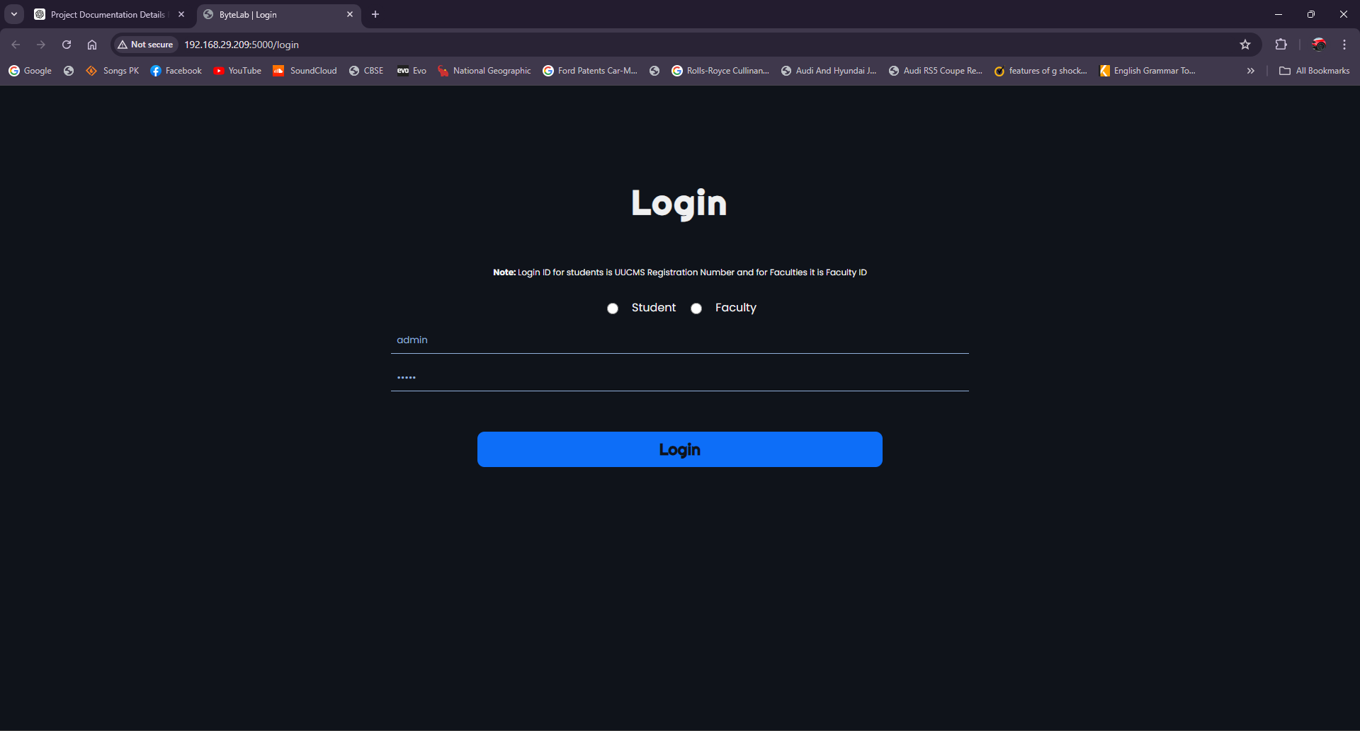
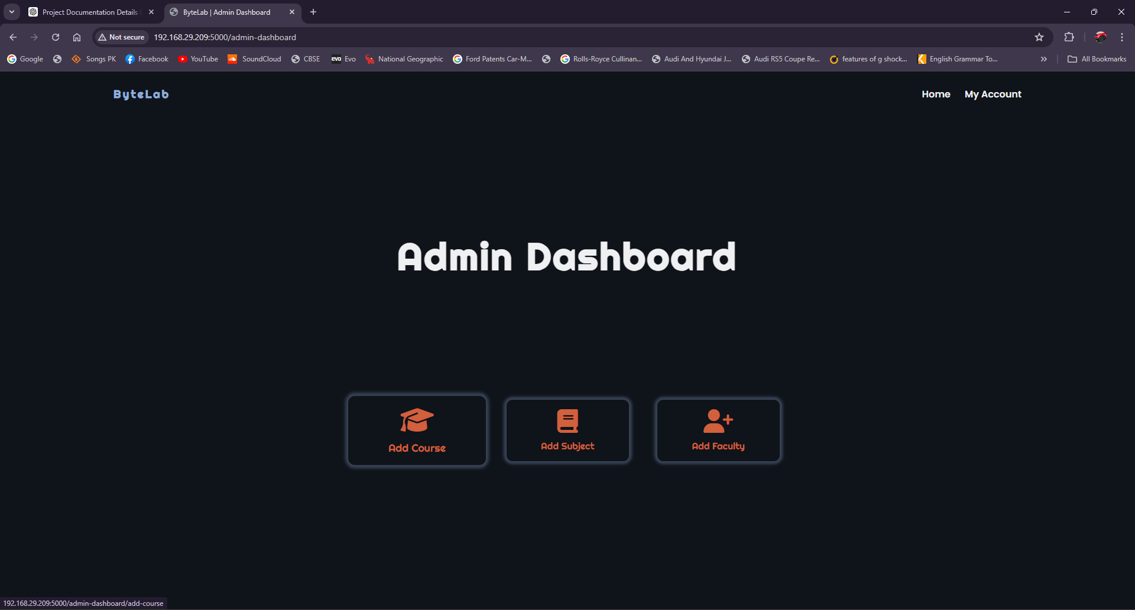

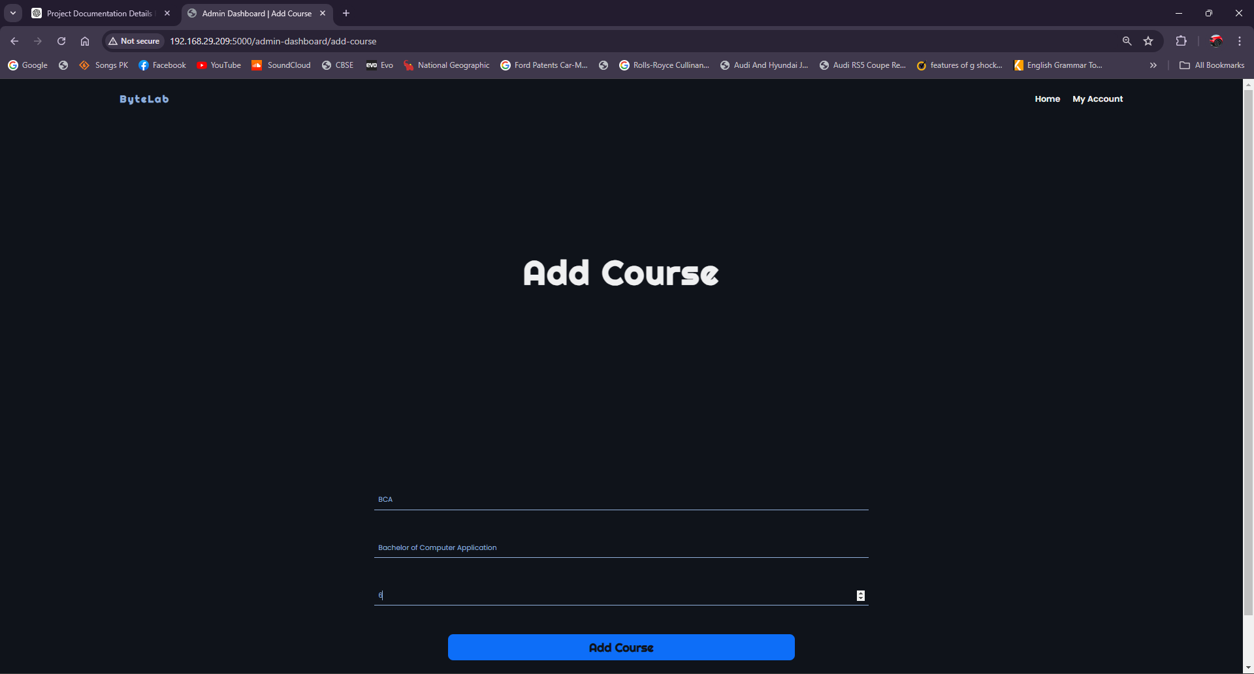

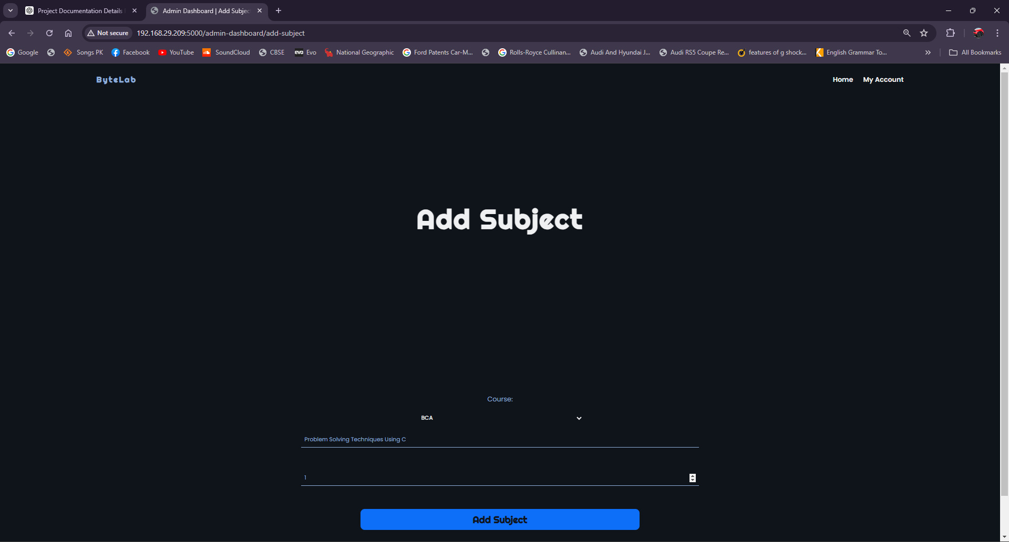

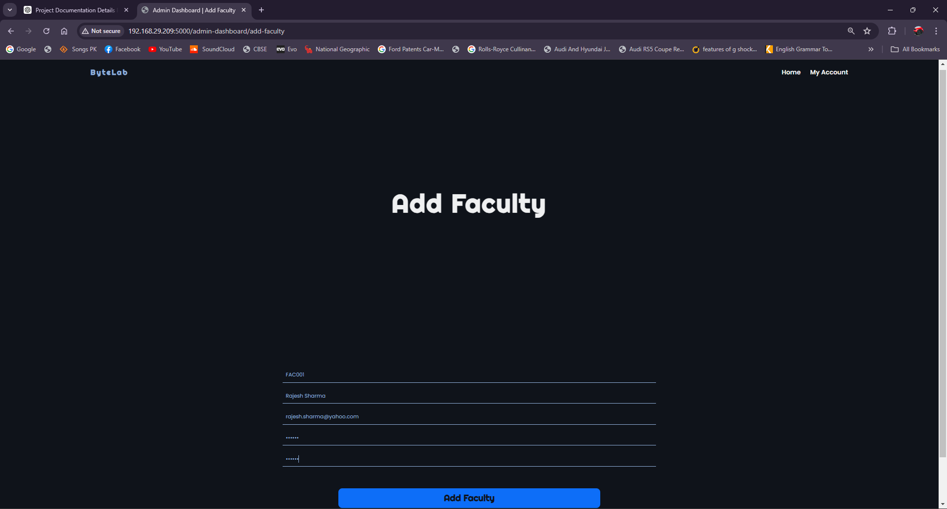

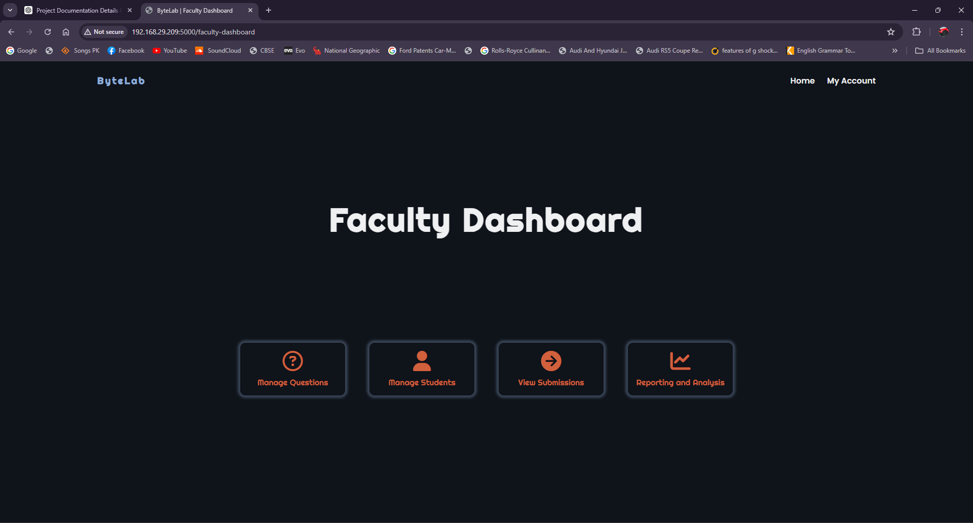

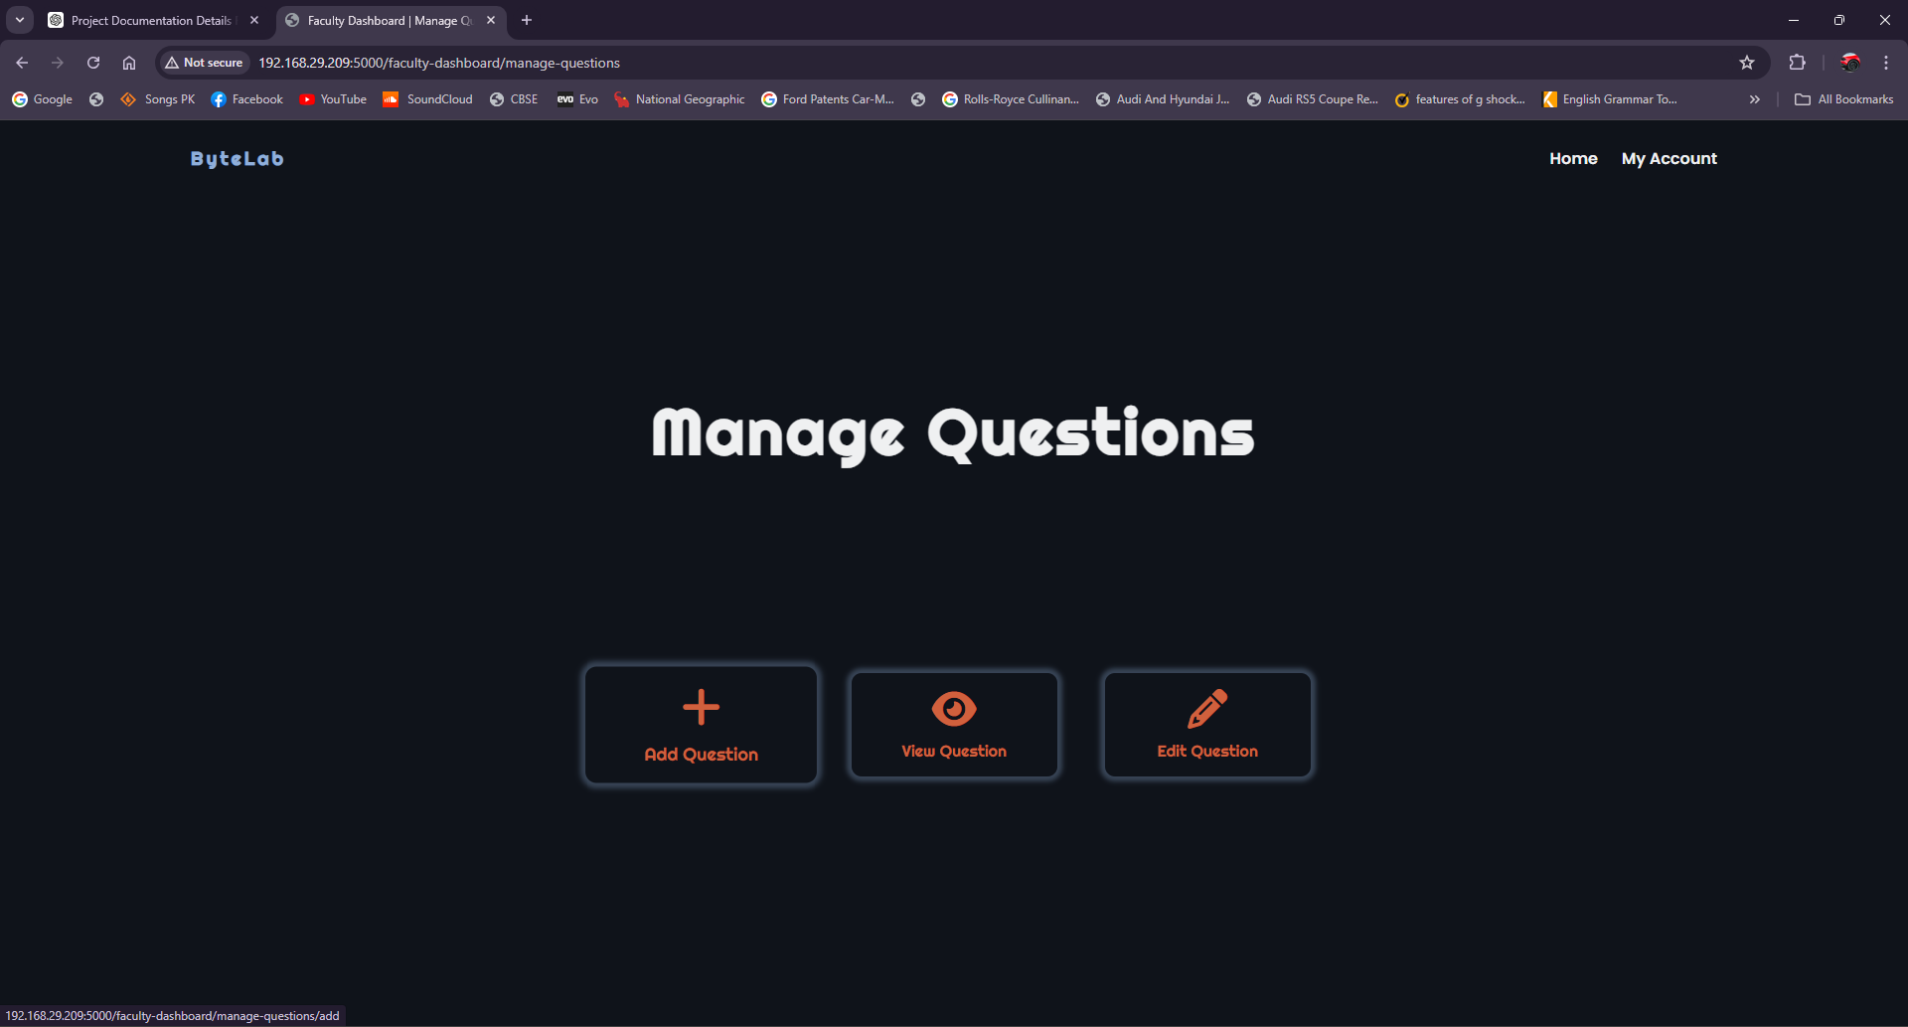

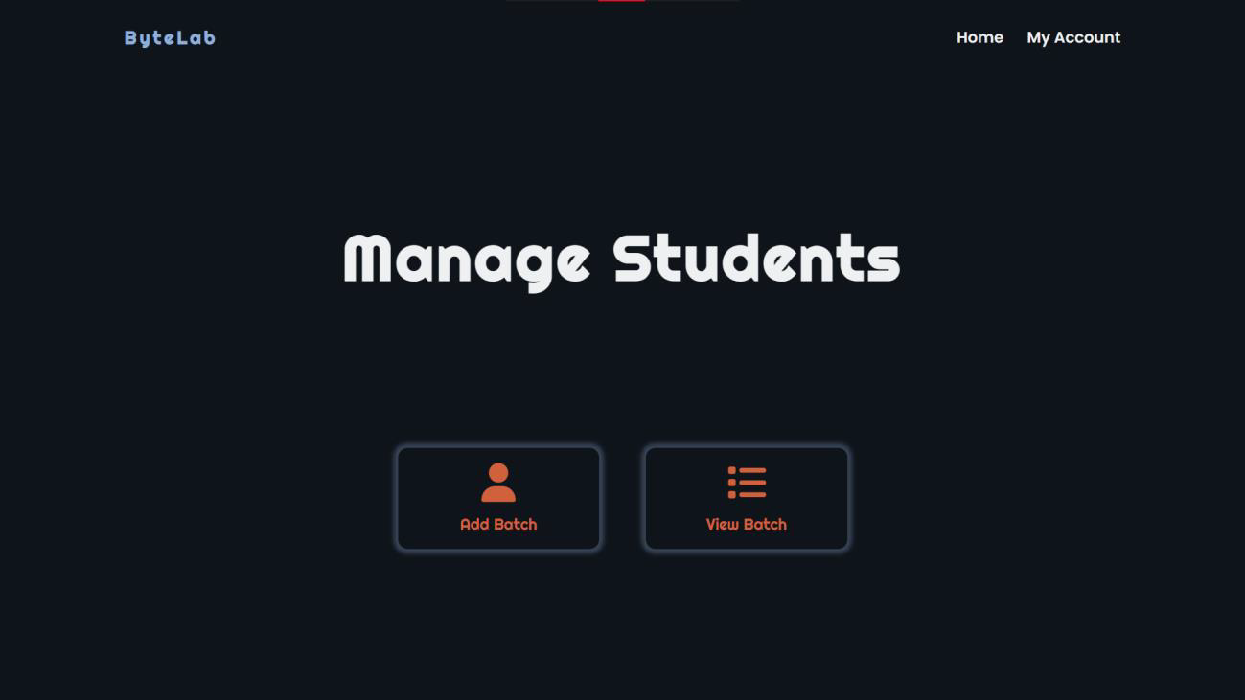

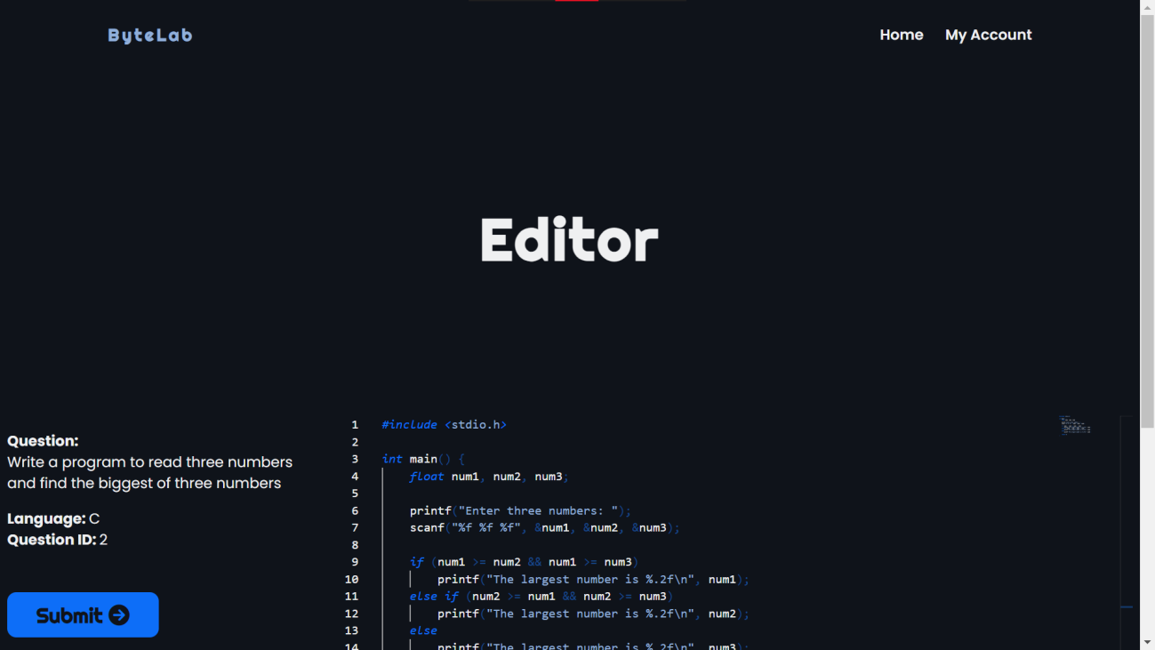

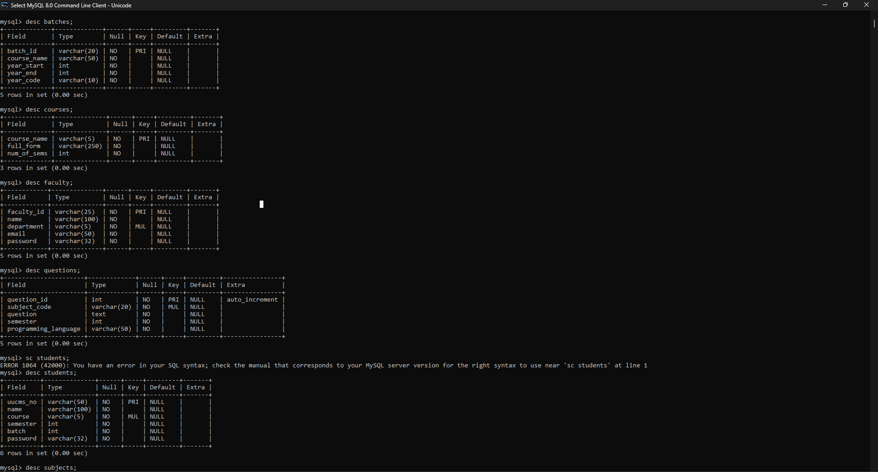

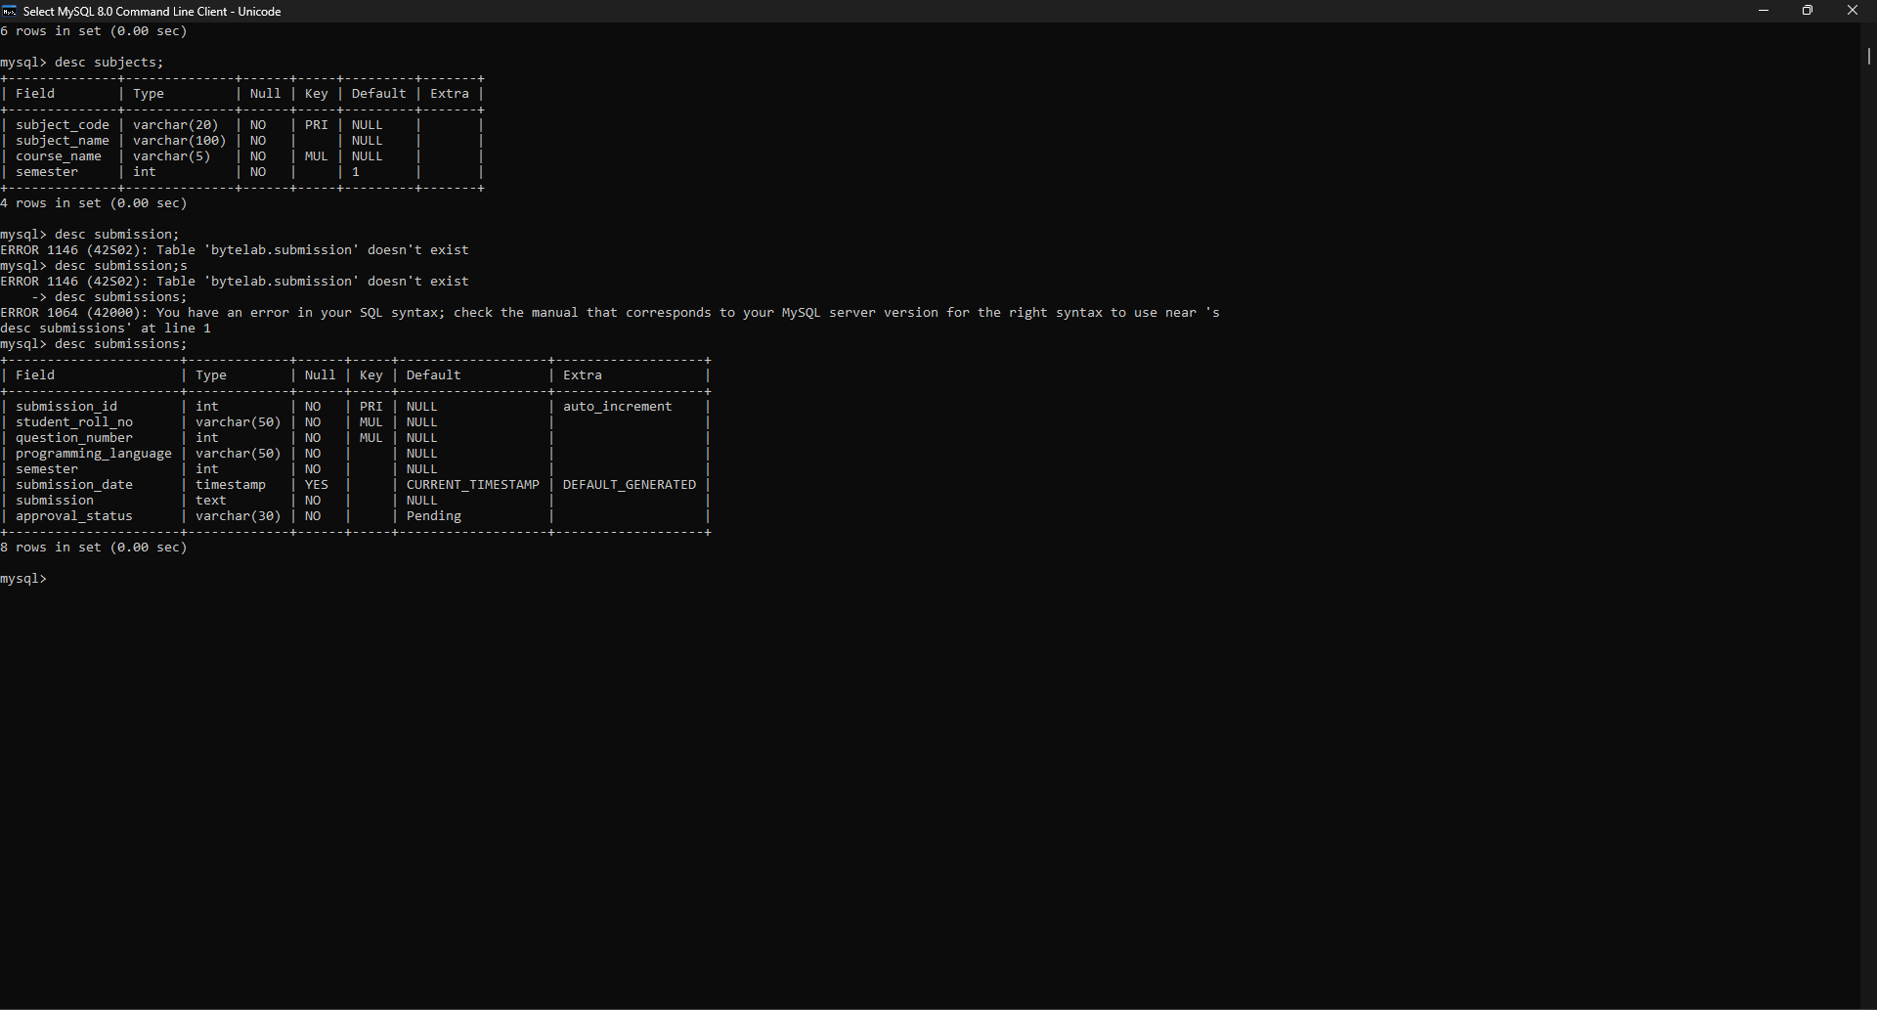

CONCLUSION
ByteLab is a comprehensive web application designed to enhance the college lab experience for both students and faculty members. By digitizing lab programs and automating the submission and assessment process, ByteLab streamlines lab sessions and promotes active learning. The iterative approach to development, including the use of the prototyping model, allowed for continuous feedback and improvements, ensuring that the application meets the needs of its users.

Through thorough testing, including unit, integration, system, acceptance, performance, security, usability, regression, database, and compatibility testing, ByteLab has been validated to perform reliably, securely, and efficiently. These tests have ensured that the application provides a seamless experience, handles data securely, and performs well under various conditions.

By offering a platform where faculty can track students' lab progress, performance, and activities, ByteLab simplifies administrative tasks and enhances educational outcomes. The system's ability to send notifications and provide real-time updates further supports effective communication and timely feedback. Overall, ByteLab represents a significant advancement in managing and enhancing the lab experience in educational institutions, fostering a more organized, efficient, and engaging learning environment.

FUTURE ENHANCEMENTS
- Advanced Analytics and Reporting: Implementing advanced analytics will provide deeper insights into student performance and lab activities. Customizable reporting options will enable faculty to track progress more effectively, identify areas for improvement, and tailor their teaching strategies to better support student learning outcomes.
- Integration with Learning Management Systems (LMS): Integrating ByteLab with popular LMS platforms like Moodle, Canvas, and Blackboard will create a unified learning experience. This will allow seamless data exchange between ByteLab and LMS platforms, facilitating better management of course materials, grades, and student progress within a single, cohesive environment.
- Gamification: Introducing gamification elements such as badges, leaderboards, and rewards can significantly enhance student engagement and motivation. By creating challenges and competitions, ByteLab can encourage collaboration and healthy competition among students, making the learning process more enjoyable and interactive.
- Virtual Labs and Simulations: Integrating virtual labs and simulations will provide students with hands-on experience in a digital format. This will allow them to practice and experiment with lab scenarios virtually before performing them physically, thus enhancing their understanding and preparedness for actual lab sessions.
- Multilingual Support: Adding support for multiple languages will make ByteLab more accessible to a diverse student body and faculty. Providing translation options for lab materials, instructions, and feedback will ensure that non-native speakers can fully participate and benefit from the platform, fostering a more inclusive learning environment.

REFERENCES
WEBSITES:
- https://flask.palletsprojects.com/en/3.0.x/
- https://microsoft.github.io/monaco-editor/
- https://github.com/microsoft/monaco-editor
- https://www.npmjs.com/package/@monaco-editor/react
- https://www.w3schools.com/MySQL/default.asp

